Alt Text for Images
Employers want their whole team to feel awesome and to not feel left out. Not only their team, but also people considering working for them.
Now, imagine you are on a team and everyone else can read the instructions, but you aren’t able to because they were provided in an image format. Imagine if you are looking for a job but the posting tells you to press the “Apply” button, but your screen reading software is only able to read out, “Button 1, Button 2, etc.”. This would make someone feel many things other than awesome.
Alt Text is a way to ensure that everyone can access and understand the information in your job advertisement, training materials, or a hiring evaluation.

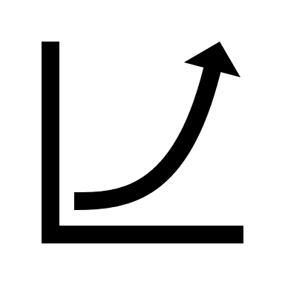
Consider this:

The document says, “You can see in the graph to the right, the trajectory of our target.” Now, imagine this graph did not have Alt Text – how would someone using a screen reader know if the trajectory is good or bad?

The document says, “We are grateful for our partner who will be conducting your training in this afternoon’s session”. The logo to the right accompanies this text. Someone with vision could associate the text with the logo beside it, but how would someone with low or no vision know who is conducting the training if there was no Alt Text?

“You will see schedules for Team A and Team B in the lounge. The schedules correspond with the colours shown with each letter.”
A
B
Now, imagine this scenario – some vision impairments will prevent people from being able to distinguish these colours and if these shapes did not have Alt Text associated with them explaining it, how would they know their colour? Also, how will they know the colour sheet of their schedule when they approach it?

Sometimes you have images in your document that are purely for decoration, and they do not provide information or directions to help the reader understand the document. Alt Text offers the option to mark shapes or images as decorative. This means those using a screen reader won’t know it is there. Close your eyes and imagine if you were listening to a document and had to keep pressing your tab button to get through a bunch of descriptions of shapes to reach the information you need. It would be a lot of time wasted.
Your business needs talent – make sure anyone with the talent you need can read your job description, website, or resource. Need support with this? Contact us!

