Accommodations and Inclusion Management: Efficient and Safe Workstations

To maximize your efficiency and safety at your workstations, ensure the following:

- Your workstation is well lit. This will help prevent eye strain and neck pain that may result from craning.
- Use a height adjustable desk. Finding a desk that is just the right height can be challenging. A height adjustable desk not only ensures that you would be comfortable using it, it also makes it possible for others to be comfortable while using your workstation.
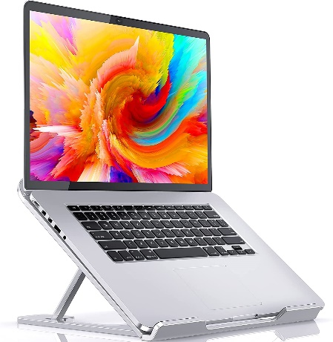
- Center your screens and keep them at the same height to reduce neck strain. The repetitive motion involved in turning your neck to view a screen can injure the neck muscles over a long period of time. Placing your screens so that you can stare straight ahead at them reduces the chance of neck strain. Height discrepancies between screens may exist especially if one uses a laptop and a monitor. A good laptop riser like the one pictured to the left (and available at the link below) will help keep both screen heights even.
- Use an external keyboard to reduce strain on your wrist while typing.
- Use a footrest like the one pictured on the left or linked below if your legs do not touch the floor.
If you require a more individualized solution, we offer Workplace Accommodation Assessments, which can help you identify what works best for you.
Click for laptop riser.
Click for footrest.

