Accommodation and Inclusion Management: Eye Strain and Lighting

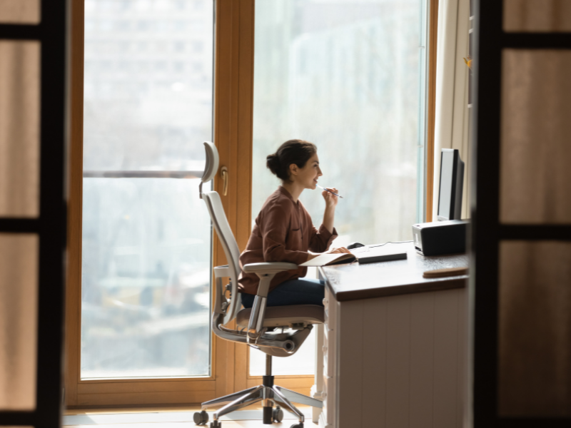
Windows and Natural Lighting
There are a lot of benefits to an office and common areas in the workplace having natural light. Natural light reduces eye stress, however, it is best to have adjustable blinds on the windows if the lighting is ever too bright for someone’s eyes.

Lighting
If lighting, for example overhead lighting, is too bright and direct, there are other solutions you can consider:
- Add a dimmable floor lamp to the space
- Use filters that can be place on the overhead lighting to diffuse the light
- Add a dimmer to the overhead lighting

Resting Your Eyes
Every 60 minutes, give your eyes a rest for 60 seconds (remember “60-60”). This will help you focus and help de-stress your eyes. Or every 20 minutes for 20 seconds, look at something that is 20 feet away.

Reducing Eye Strain from Monitor/Laptop Use
If monitor viewing is contributing to someone’s eye strain, there are settings you can adjust to help:
- Adjust brightness/contrast, use light colour for background
- Increase font size using keyboard shortcuts for your operating system
- Make mouse pointer large and black
- Place the monitor parallel (rather than directly below) overhead lights. Angle monitor away from lights/windows
- If using a task light, ensure it is focused on illuminating document and not the monitor to avoid a glare on your monitor
Contact us for individualized support with your workplace at aim@ccrw.org.

