Accommodation and Inclusion Management: Headsets

Compatibility
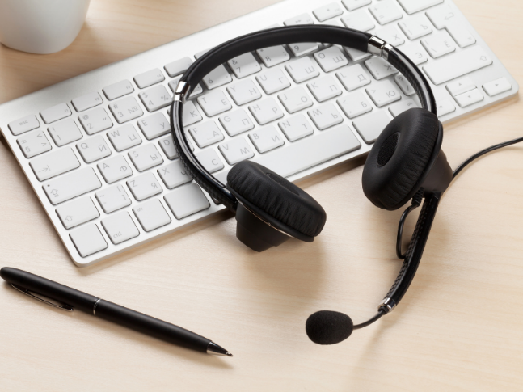
If the headset is connecting to a phone (and not a computer) you need to get the make and model of the phone and research what headsets are compatible with it.
If you are looking for a headset that can be used and switch between on multiple devices, there are considerations to make.
- If it is a wireless headset, explore if the option you have or are getting offers additional hardware for connecting across multiple connection signals.
- If you are using or want a wired headset, you can purchase a device called the Plantronics MDA220 USB Headset Amplifier that allows for the headset to be connected to multiple devices.

Wired vs. Wireless
Choosing wired or wireless comes down to personal preference. The individual may want to consider:
- How much movement they do each day.
- Wireless headsets can be more expensive.
- Some wireless headsets require you to answer the call on the device it is communicating with (phone/ computer). You can purchase an accessory called the Electronic HookSwitch, which allows users to answer and hang up using controls through the headset.

Other Considerations:

Common Brands
- Jabra
- Plantronics/ Poly
- Logitech
- Do you want binaural (covering both ears) or monaural (only covering one ear)?
- Do you want a headset that goes over the ear, covers the ear, in-ear, convertible, etc.?
- Do you require a headset with noise cancelling features (consider the environment of the worker)?
Contact us at aim@ccrw.org for more resources and support!

