Accommodations and Inclusion Management: Accommodating Remote Work

When people are working from home as an accommodation, like any accommodation, there are important considerations to make. This guide will help you make sure you have the necessary conversations to make this accommodation a success.

Work-from-Home Settings and Distractions
- Distractions when working from home can come from various sources (for example, multiple people working in a confined space, children at home, pets, housework, etc.)
- Interruptions at home can impede on an individual’s ability to work
  - If distractions are unavoidable, notify family members of times that they cannot distract you, for example during important meetings or presentations
- It is important to set boundaries between work-life, family-life, and home-life to optimize concentration and minimize interruptions
- If possible, work in a quiet, closed space to allow for optimal distraction-free working conditions

Work-Life Balance and Imbalance
- When work is brought into the home, boundaries can blur
- Difficulty disconnecting from work (both mentally and physically) leads to extended workdays, which can impede on work-family life and work-home life
- Some argue working from home allows them to be more involved in parenting and household responsibilities during the day – activities typically completed in the evenings
- Have a designated working area that’s separate from your bedroom / kitchen, if possible.
  - This will help with disconnecting from work at the end of the workday
  - When working in a space that’s shared with relaxation time, or chores, it’s hard to separate work-life from home-life

Mental Health and the Emotional Toll that can Happen Working From Home
Working from home can be isolating. However, there are positive aspects for mental health that can happen working from home:
- More time for socializing with friends and family
- More time for sleep or exercise
- Less need for recovery time after work
- More employee control over interactions with colleagues
- More control on the day’s schedule to promote flexibility
Here are some potential negative aspects on one’s mental health to watch out for when working from home:
- Psychological and physical isolation
- Lack of spontaneous interactions with colleagues
- The assumption of availability beyond regular work hours
- The difficulty for employees to disconnect post-work

Physical Considerations
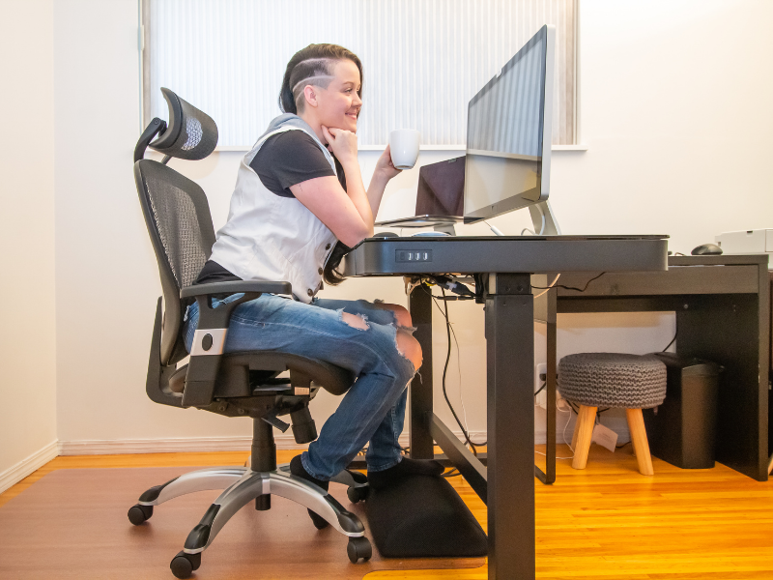
Working from home can impact a person’s body in different ways. Here are some common physical challenges people face when working from home:
- Sedentary lifestyle: It is important for people who work from home to build movement into their workday (for example, standing up to move around for 2 minutes every 30 minutes)
- Poor seating posture can contribute to rounded shoulders, headaches, and overall muscle fatigue due to restricted blood flow to the limbs
  - Workplace sitting posture should include sitting with a straight back without hunching and the buttocks touching the seat’s end.
  - The neck and head should be in an upright position with the ears and shoulders aligned and without leaning the body to either side.
- Standing desks are often recommended to reduce pressure on the lower back and neck, and reduce blood flow constriction in the legs that occurs while sitting
- An ergonomic workstation (check out www.ccrw.org for a resource about this!)

Operational Considerations
There are operational considerations that managers should make when supporting a worker who is working remotely:
- Ensure they are connecting frequently with their team since they will miss organic social interaction working remotely
- Ensure any conflict between the remote worker and those on-site are resolved quickly as sometimes the effort to find a time for a virtual call can cause a delay in a resolution. Whereas in-person it is easy to have an impromptu side conversation. Affirm everyone involved of work towards a solution to avoid the accommodation being stigmatized.
- Have conversations with the employee about conversations that should happen over a call and what conversations can happen over email
- Make sure their Supervisor is connecting with them more frequently to see how things are going
- Ensure they have all the furniture and technology they need to work safely and efficiently from home
- Will they be working from home full time or part time? If it is part time, set a schedule and communication practices so people can know when to expect them in the office.

CCRW can support you in the accommodation process and figuring out all these details. We will give you the tools to be successful going forward. Contact us at aim@ccrw.org to learn more.

