SAMPLE COVER LETTER – PARAGRAPH STYLE
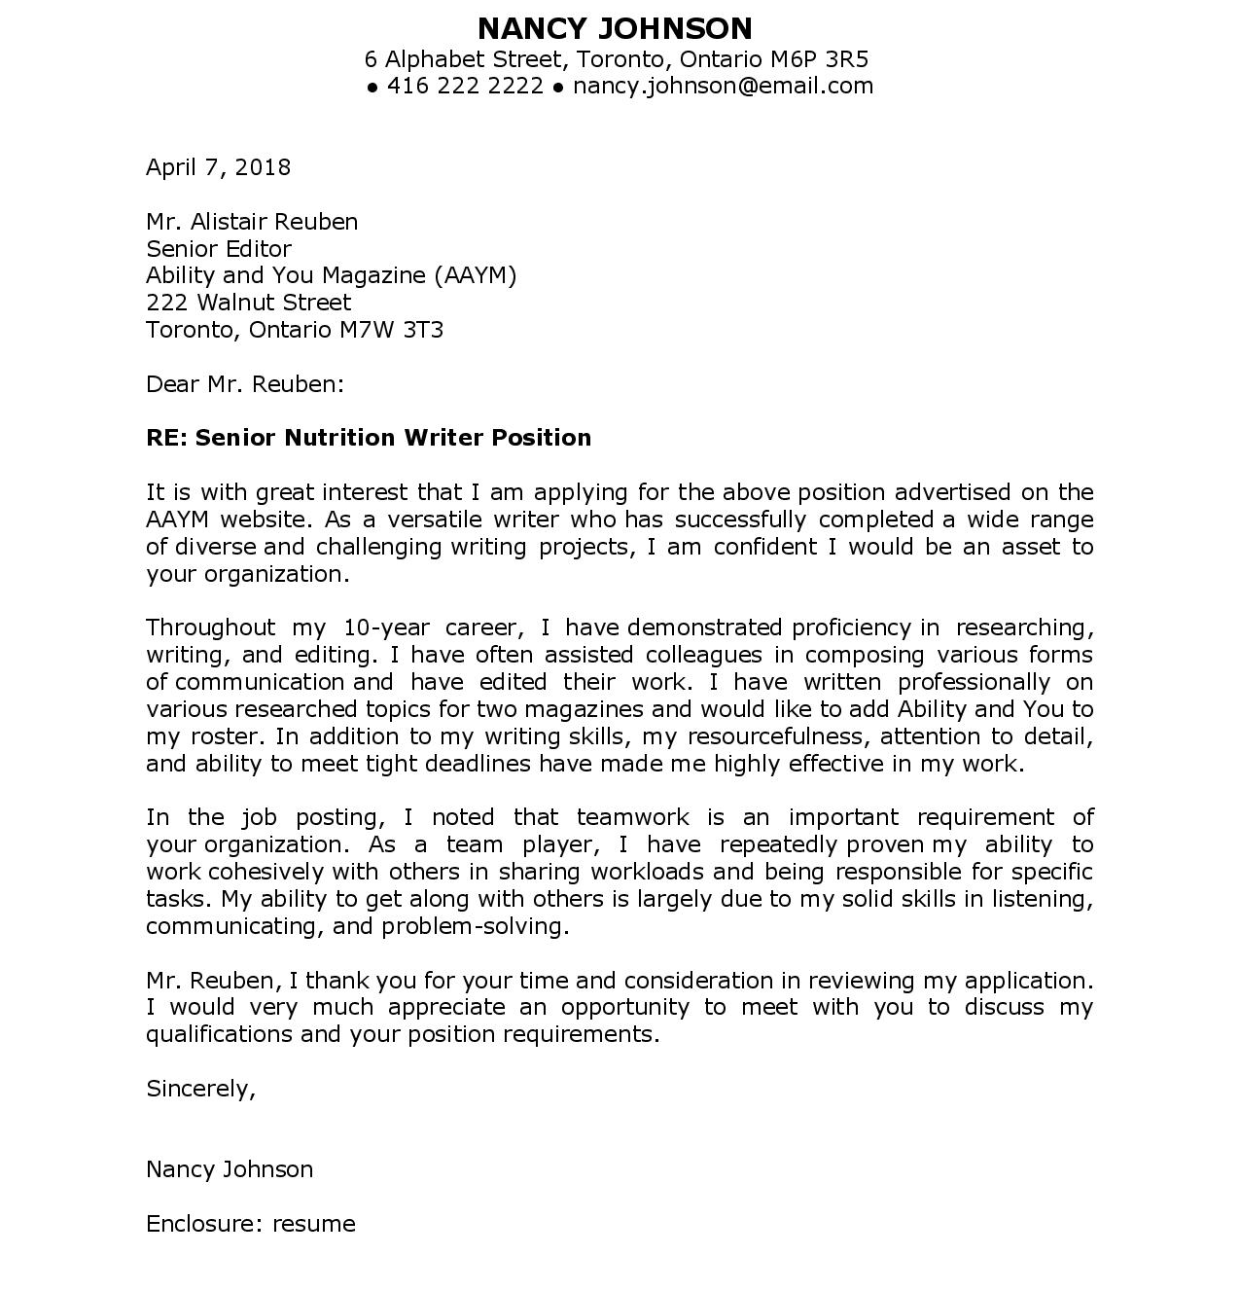

SAMPLE 1: BULLETED LIST STYLE

CATHERINE REYNOLDS
6 Alphabet Street, Toronto, Ontario M6P 3R5
● 416 111 1111 ● cathyr@email.ca

July 10, 2018

Raymond Jones
Manager, Research Department
Weckman’s Ltd.
123 Letter Street
Toronto, Ontario M7W 3T3

Attention: Raymond Jones

It is with great interest that I am applying for the Administrative Assistant, Research Department position advertised on the Weckman’s Ltd. website. As an administrative professional dedicated to my field, I am confident I would be an asset to your company.

Relevant to your requirements, I offer:

- 10 years’ administrative experience in various work environments
- Effective researching, writing, and editing skills
- Proficient user of MS Office Suite programs
- Organized multi-tasker who pays attention to accuracy
- Solid time management skills, consistently meeting tight deadlines
- Supportive team player, reliable and flexible
- Bi-lingual in English and French

I thank you for your time and consideration in reviewing my application. I look forward to hearing from you to discuss next steps regarding this opportunity.

Sincerely,

Catherine Reynolds

Attachment: resume

COVER LETTER SAMPLE WITH DISCLOSURE

CATHERINE REYNOLDS
6 Alphabet Street
Toronto, Ontario M6P 3R5
416 111 1111
cathyr@email.ca

April 15, 2018

Robert James
Manager, Research Department
Wiley Communications Ltd.
123 Slater Street
Toronto, Ontario M7W 3T3

Attention: Robert James

I am very pleased to apply for the Administrative Assistant, Research Department (job #46423) position advertised on your company website. As an applicant who identifies with two of the designated groups, I appreciate Wiley’s equity initiatives and diverse workforce. I am confident my wide range of relevant skills and dedication to my field will make me an asset to the Wiley Communications team.

The following is a profile of my skills related to the position:

- 10 years of administrative experience in various work environments
- Effective researching, writing, and editing skills
- Proficient user of MS Office Suite programs
- Organized multi-tasker who pays attention to accuracy
- Solid time management skills, consistently meeting tight deadlines
- Supportive team player, reliable and flexible
- Bi-lingual in English and French

Thank you for your time and consideration in reviewing my application. I would welcome the opportunity to meet with you to discuss my qualifications for this position.

Sincerely,

Catherine Reynolds

Attachment: resume

COVER LETTER SAMPLE: DISCLOSURE/ATTENTION LINE

DANIEL PETERS
37 Baltray Crescent
Toronto, Ontario M3A 2H3
416-000-0000
danielpeters@email.com

April 15, 2018

Hiring Manager/ Committee
Taylor Communications
taylorcomm@taylor.org

Attention: Hiring Manager/ Committee

With great interest, I am responding to the Administrative Assistant (job #212689) position posted on Workopolis.com. Knowing your company is an equity employer, I am inspired to apply, as I identify with one of the designated groups. I am confident that my combined experience in the administrative and customer service fields will make me an asset to the Taylor Communications team.

The following is a summary of my skills matching your position requirements:

- Over five years’ experience running a successful event planning business
- Solid administrative skills including document preparation, editing, and merging
- Proficient user of Microsoft Office Suite programs
- Excellent time management, consistently meeting tight deadlines
- Professional customer service and communication skills
- Efficient team player who also works well independently
- Conscientious multi-tasker who is highly organized and detail-oriented

Thank you for your time and consideration in reviewing my resume and cover letter. I look forward to hearing from you at your earliest convenience regarding this opportunity.

Sincerely,

Daniel Peters

Attachment: resume

COVER LETTER SAMPLE: PARAGRAPH STYLE
CONTACT PERSON IN AD: “Mr. Alistair Reuben”
SUBMISSION METHOD: REGULAR MAIL

SAMPLE JOB POSTING: EDITOR

Greenway Publications Ad

Greenway Publications, a leading Canadian publisher of fiction and non-fiction books for all ages, is seeking an editor to work in our very busy editing department. The successful candidate will work with a team of five, led by our Senior Editor.

Required skills are as follows:

Editing and writing experience
Detail-oriented
Able to work effectively in a team and independently
Must be able to multi-task without compromising accuracy
Highly organized
Solid time management skills
Bi-lingualism in English and French an asset

Interested applicants must forward cover letter and resume to:

Nancy James
Senior Editor
Greenway Publications
123 Blue Street, Suite 90
Toronto, Ontario M2P 3W3

Deadline: April 20, 2018

Only those selected to be interviewed will be contacted.

COVER LETTER SAMPLE: RESPONSE TO ABOVE AD

JONATHAN ROGERS
10 Primrose Lane
Toronto, Ontario M2W 1T7
416-222-2222
jarogers@umail.com

April 5, 2018

Nancy James
Senior Editor
Greenway Publications
123 Blue Street, Suite 90
Toronto, Ontario M2P 3W3

Attention: Nancy James

RE: Editor Position

As a professional editor, I am very interested in the above-noted capacity currently advertised on your company website. I am confident that my combined experience in editing and writing will make me a strong candidate for this position.

Relevant to your requirements, my profile is as follows:
- Detail-oriented editor and versatile writer
- Reliable, supportive team player who also works well independently
- Solid skills in multi-tasking, ensuring accuracy
- Well-organized with excellent time management skills, consistently meeting deadlines
- Recipient of various creative writing awards
- Published author of accessible children’s books in multiple formats, a teaching toolkit, and magazine articles
- Appeared on television to promote the accessible material noted above
- Secured a million project dollars over four years through my proposal-writing

I would welcome the opportunity to meet with you to discuss my candidacy and details regarding this dynamic position. Thank you for taking the time to review my application, and I look forward to hearing from you in the near future.

Sincerely,

Jonathan Rogers

Attachment: resume

SAMPLE JOB POSTING: Teacher

Job Advertisement (Service Canada Website)
Job Number: 4919188
Title: Teacher for children with autism
Employer: Stepping Stones Fundy Region Inc.
Business Profile: This is a treatment centre for children with autism.
Terms of Employment: Permanent, Full-time, Day
Salary: To be negotiated
Anticipated Start Date: As soon as possible
Location: Saint John, New Brunswick (2 vacancies)
Education: E.C.E. or equivalent and at least one year of experience working with children who have special needs

Languages: Speak English, read English, write English

Target Groups or Clients: Children with autism

Specific Skills: Assist students in developing life skills

Security and Safety: Criminal record check, child abuse registry check

Work Conditions and Physical Capabilities: Fast-paced environment, attention to detail, bending, crouching, kneeling

How to Apply:
Please apply for this job only in the manner specified by the employer. Failure to do so may result in your application not being properly considered for the position.

In Person between 9:00 and 17:00:
61 Millidge Avenue
Saint John, New Brunswick E2K 2M2

By E-mail: jamieguthrie@steppingstonesfundy.com
Web Site: https://www.steppingstonesfundy.com
Advertised until: 2018/04/10

COVER LETTER SAMPLE: RESPONSE TO ABOVE AD

SUSAN JEFFERY
10 Holiday Way
Mississauga, Ontario L4G 2T5
905-555-5555
susanj@email.ca

March 29, 2018

Jamie Guthrie
Stepping Stones Fundy Region Inc.
61 Millidge Avenue
Saint John, New Brunswick E2K 2M2
jamieguthrie@steppingstonesfundy.com

Attention: Jamie Guthrie

I am very pleased to apply for the position of Teacher for children with autism (job # 4919188) advertised on the Service Canada website. As a seasoned Life Skills Specialist who has worked extensively with children who have autism, I am confident that I would be an asset to the Stepping Stones team.

Relevant to your requirements, my profile is as follows:
- Over 10 years’ experience teaching life skills to adults and children with social barriers
- Created a wide variety of individualized and group activities / programs
- Solid listening and communication skills, verbal and written
- Fully bi-lingual in English and French
- Highly experienced in behaviour / crisis management
- Excellent research and problem-solving skills
- Critical thinker with sound decision-making skills
- Enthusiastic team player, passionate about empowering people

Thank you for your time and consideration in reviewing my application. I have family in Saint John and am planning to relocate to your city to continue my career in the life skills field. I look forward to further discussion with you about this dynamic position and how I can contribute to the continued success of your program.

Sincerely,

Susan Jeffery

Attachment: resume

