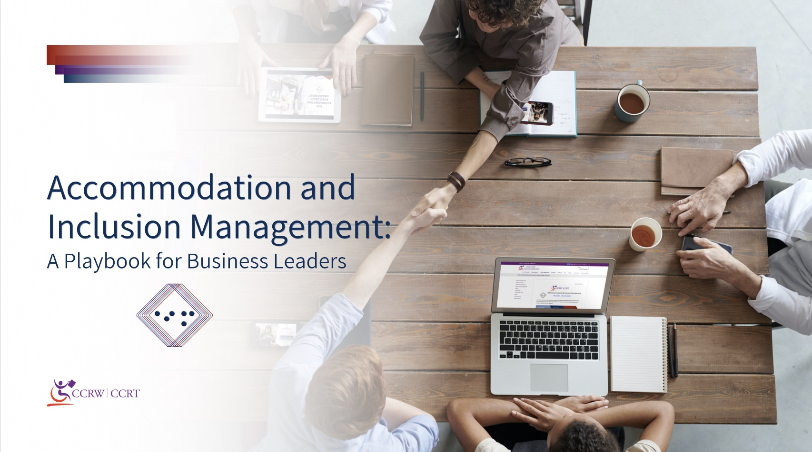

We developed this playbook to inspire change among Canadian businesses.
The playbook offers a blueprint to anyone who is interested in advancing accessibility and creating inclusive workplaces. Using a research-informed and intersectional approach, CCRW has carefully crafted five recommendations, or ‘plays’ as we call them, to guide your thinking when engaging in an accommodation process with an employee.

Contents

Prologue 4
A Guide to Using This Playbook 6
Message from CCRW 9
Play 1-Stay ahead of the game: Rethink disability 14
Play 2-Are you ready? Prepare 18
Play 3- Go the distance: Identify a process 22
Play 4- Hit your mark: Review, evaluate, evolve 25
Play 5-The ball is in your court: Build your disability confidence 29
Moving Forward 32
References 34

Prologue
Accommodation and Inclusion Management (AIM) offers a roadmap to help navigate the COVID-19 economic recovery while simultaneously preparing business leaders for the future of more flexible and adaptive workspaces. COVID-19 has presented a singular opportunity for business to reform their thinking concerning disability and accommodation. Before the COVID-19 pandemic, many employees did not feel comfortable disclosing information about a disability or a workplace barrier to their employer. While there may be many reasons for this, it often comes down to trust and communication issues between the employee and employer. COVID-19 has further augmented these concerns, as business across Canada has had one of its most challenging years 1.
At the core of workplace accommodation is open, trust-based communication between an employer and its employees. As a goal, a company must cultivate an atmosphere where learning conversations can occur around disability. As much as possible, the intention is to remove the medicalized lens and help employees feel comfortable requesting and discussing potential accommodations. Employees need to know they will be a driver in their accommodation process, to have their stories heard, and know they will be taken, as much as possible, at their word. As these fundamentals of reasonable accommodation develop, an organization can witness trust grow in the relationship with their employees.
Defining in advance the parties that will communicate is a building block of effective communication. Empowering the frontline manager to handle most of the conversations related to accommodation and its implementation should be the norm4. This approach builds trust and makes the manager able to follow-up and be present for any requests to modify the accommodation after its completion. For more complex accommodations, and at the employees' request, an organizational approach beyond direct managers would also need to be established.
Historically, workplace accommodations have revolved around removing barriers to participation based upon an individual's disability. This playbook offers a new perspective: accommodating employees based on obstacles to success/ productivity, medicalized or not, and moving from accommodation to adjustment. It presents how to evolve workplace accommodation as an experience all employees can benefit from. It would signify a shift away from considering disability as the only legitimate reason for requesting accommodation, to considering potential productivity gains accommodations can provide^{5,6} .
The provision of adjustments to accommodate employees in the workplace will significantly help develop inclusive work cultures^{7,9}. As business transitions from accommodation to adjustment, it inherently demonstrates its commitment to diversity and inclusion for all employees, not just those with lived experience of disability. This universal approach foregrounds the importance of intersectionality and recognizes how an employee may possess multiple identities, with disability being only one of them. Growth of this nature can maximize employees' work experience and help them be their best selves as employees and people in the workplace.
Accommodation supporting all workers, rather than merely mitigating disability, can directly impact your organization's wellness, bottom line, and inclusivity. AIM aspires to do this while also destigmatizing and de-medicalizing accommodations to maximize workforce productivity and engagement. Your organization can be a leader and early adopter of an accommodation system that generates these positive outcomes. Our intention in presenting this playbook is to provide a compendium to AIM the service that can deliver strategies that will maximize AIM's impact.

"Launching a new business at the height of the pandemic was challenging. But at LoveFoodToGo we committed right from the beginning to ensuring that our teams had the right equipment for the tasks we needed them to complete. We also changed up our normal scheduling practices. For us- schedule flexibility was a key consideration for the wellbeing of our employees as we transitioned into a new work reality."
Vincenzo Guzzo,
CEO of Cinema Guzzo and LoveFoodToGo

A Guide to Using this Playbook
Audience
This playbook offers curated, best-practice guidance for hiring managers, frontline managers, and supervisors who have the capacity to implement individual, yet highly effective changes to meet the needs of employees.
Moving Through the Plays
We recognize that disability is diverse - no two people experience disability the same way. In a similar sense, no two employees should share the same accommodation experience. As you move through the plays, note that we do not intend to be prescriptive or provide in-depth ‘how-tos’ for you to follow point-blank. Instead, our playbook outlines a broad approach to conducting accommodations grounded in best-practice. We challenge you to apply each play in a tailored, flexible, and thoughtful manner.

“With more than one billion people with disabilities in the world, we believe accessibility and inclusion are essential to delivering on our mission to empower every person and every organization on the planet to achieve more. That doesn’t just begin and end with the products we create. To enable transformative change, accessibility needs to be a priority. It’s about ensuring that inclusion is woven into the fabric of what we design and build for every team, organization, classroom, and home.”
Ricardo Wagner,
Microsoft Accessibility Lead

Language and Tone
Across countries, cultures, and specific contexts, disability can be conceptualized, understood, and spoken about in varying ways. Importantly, disability discourse – how we write or speak about disability– has the power to shape prevailing narratives as well as our personal perceptions of disability.
Within this playbook, CCRW has strived to utilize language and tone in a clear, appropriate, and respectful manner to uphold the dignity and rights of persons with disabilities. We have worked in close partnership with Canadian business leaders and individuals with lived experience of disability to produce a novel and user-friendly resource that celebrates disability, diversity, and inclusion. The term ‘workplace accommodation’ is commonly referenced in Canadian business and has been used within federal and provincial legislation¹⁰, as well as the Convention on the Rights of Persons with Disabilities¹¹. However, the term ‘workplace adjustment’ has also gained traction in the international arena.
In our work, both terms will be used to describe the routine, necessary, and appropriate modifications (i.e., adaptive tools, technology, flexibility, etc.) that enable an employee to perform essential duties of their job, experience equitable employment, and reach their potential on an equal basis with others.
Canadian employers have a legal ‘duty to accommodate’, which requires them to not only identify and remove barriers with adverse impacts on employees with disabilities, but empower employees to work to the best of their abilities (CHRA, 1977; Government of Canada, 2011).
Lastly, we recognize that under the umbrella term of ‘workers’, there are both employees and independent contract workers. Given we will refer to the employer/employee working relationship frequently in the playbook, we will use the term ‘employees’ to refer to all types of workers.
Message from CCRW, CEO
CCRW believes Canada is strong because of our diversity. Our diversity naturally creates innovation which breads talent. It is with this talent that Canadian businesses succeed and thrive. Sometimes it can be confusing to understand how to embrace the diversity of our people, as we need to think differently about how we do things, to challenge the status quo and become inclusive by design. Change in organizations need to come from the top – CEOs and business leaders need to embrace diversity in the workforce that will then influence the attitude shift that is needed.
Attracting talent is important, but once workers are in the door, how do we retain the talent and innovation present? How do we work differently to ensure productivity and a healthy workforce? What types of adjustments need to be made to the workplace and what type of accommodations need to be provided to the diverse workforce? How do we start those conversations in a meaningful way that will result in solutions? These questions are the starting point for any company who wants to ensure their success is sustainable with diverse talent. And because diversity includes disability, CCRW is honoured to support Canadian businesses in their journey to disability confidence.

Maureen Haan, CEO

Message from CCRW,CBDO
CCRW provides credible, innovative and inclusive employment solutions, and we are proud to introduce AIM: Accommodation &amp; Inclusion Management. With employees working from home or returning to work, accommodations and adjustments in the workplace are more important than ever. It is critical that we learn how to respond to the needs of our employees, while building trust and establishing a sense of belonging: inclusion matters.
Developing an accommodation strategy ignites an opportunity to expose the variables of perspective needed to facilitate problem solving, innovation and healthier work environments. There is an advantage in acknowledging our differences which can help solve talent gaps and drive business essentials.
CCRW encourages leadership by building disability confidence. We instruct in strategic inclusive hiring methodologies and help build a resilient workforce that can adapt to changing business models. We encourage business leaders to influence practices by being equitable; mindful of intersectionality. We have designed Accommodation and Inclusion Management to help implement a solution that is consistent across individuals; one that is streamlined, efficient and valued.
AIM: for an inclusive employment path to an enhanced workforce.

Jamie Burton, Chief Business Development Officer

"Creating a mindset for change is a process that moves individuals from being unconscious and reactionary to being creative and intentional."

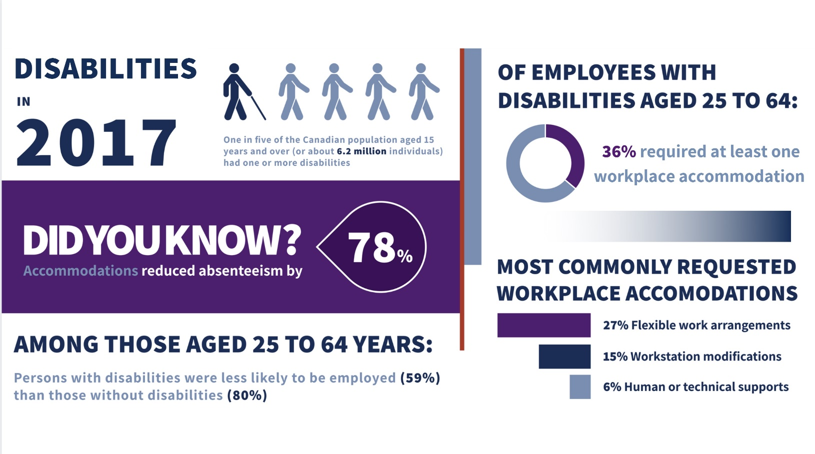

"The pandemic has sped up the pace of change for how we work and conduct business in Canada. At the outset we realized how important it was for our team to have the necessary tools, workforce structure and skills in place to be successful."
Tracie Tighe, Executive Producer,
CBC Television, Dragons’ Den

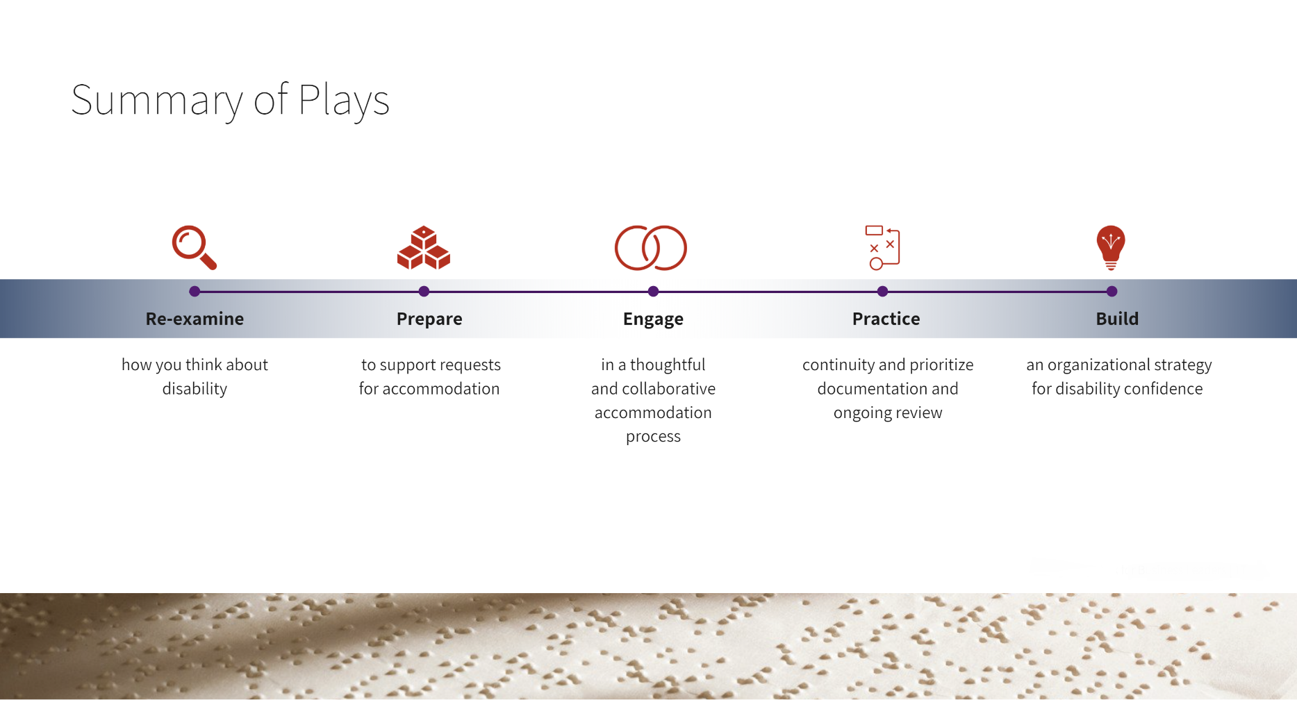

- Stay ahead of the game: Rethink Disability
The highlights:
-Understand that disability is diverse
-Consider the disability identity
-Re-shape negative attitudes
The time has come for employers to strike down barriers to employment and accommodation, which prevent far too many individuals from meaningfully contributing to their economies and communities. For any business, your first step is rethinking disability.
Understand that Disability is Diverse: Disability comes in a variety of different forms. While most employers can quickly identify and provide accommodations for persons with visible disabilities, other types of disabilities that are less apparent may not be as well understood or even recognized. This lack of awareness might lead you to or dismiss opportunities to support your employees with disabilities, just because they do not ‘appear’ to need accommodations^{3,12}. Without proper accommodations, employees can struggle at work - hindering their ability to reach their full potential and thwarting your business through lost productivity, absenteeism, and decreased morale^{13,14} .
Though this is problematic, if you are committed and informed, you can successfully address this issue.
Rather than subscribing to dated understandings of what disability should look like (i.e., “I need to see it to believe it”), we challenge you to turn the corner. Broaden your understanding of disability and adopt an inclusive approach to accommodation. Actively seek out opportunities to gain knowledge. Remember, when you meet your employees’ needs with flexibility, individualization, and open-mindedness, you win too.
Consider the Disability Identity: Disability, illness, and injury – whether acute, chronic, or episodic – are a shared experience. Did you know that there are more than 6.2 Canadians currently living with disability¹⁵? This represents the only minority group that any one of us can become a member of at any time.

Disability Confidence with Marco Pasqua
Provide Disability Awareness Training: This can be done through an external service or introduced through internal employee resource groups / lunch and learns or virtual training sessions. In some cases, you might even have an employee with a disability who is willing to come forward and share their story (just make sure you ask them first).

The experience of disability cannot be limited to a long list of health conditions. What is disabling in one setting, may not be disabling in another setting (e.g., while someone with dyslexia may experience barriers in an office, they can participate fully in an industry such as construction).
For employers, the importance lies within recognizing when, where, and how you can equip an employee with what they need to succeed. Hand-in-hand with rethinking disability, is adopting an intersectional approach. Employers need to understand that while the disability identity must be acknowledged, it is not a person’s sole identity.
Intersections between disability, gender, race, indigeneity, age, poverty, and more, may compound and create further barriers to fair and equitable employment^{16,17}. Take the time necessary to learn about these statuses, how they can interact, and what you can do in the workplace to mitigate discrimination.
Re-shape Negative Attitudes: One of the most salient barriers for people with disabilities in the workplace – or in any context – are negative underlying attitudes^{18,19}. At the core of it, is misinformation and misconceptions (e.g., people with disabilities are warm but less competent¹⁹, and so on).
Not only do these tend to impact how an employer views accommodation for an employee or candidate with a disability, but they influence hiring decisions and corporate culture as well^{20,21.} As we know all too well, negative attitudes towards people with disabilities can lead to stigmatization and exclusion in the workplace^{22,24}. Fortunate for us, attitudes are learned and can be relearned. Challenging our own biases takes time and requires ongoing discussion, education, and contact^{25,27}.
"The dimensions of diversity and inclusion and intersectionality can only be addressed with the support of our employees, clients, customers and like-minded partners. I am humbled to guide this work in Canada and to continue working with our stakeholders across the country, including CCRW, to improve the Quality of life for all Canadians."
Normand St. Gelais,
Director of Corporate Responsibility, Sodexo Canada
Conversations can be liberating – they can bring to light alternative perspectives or innovative solutions and determine important steps towards disability inclusion moving forward. To get the ball rolling, consider:
- Engaging with and learning directly from persons with disabilities
- Connecting and partnering with advocacy groups in the disability sector
- Forming listening groups with employees with a disability
- Planning speaker series and workshops that focus on disability and diversity
- Participating in community-based events and initiatives supporting disability

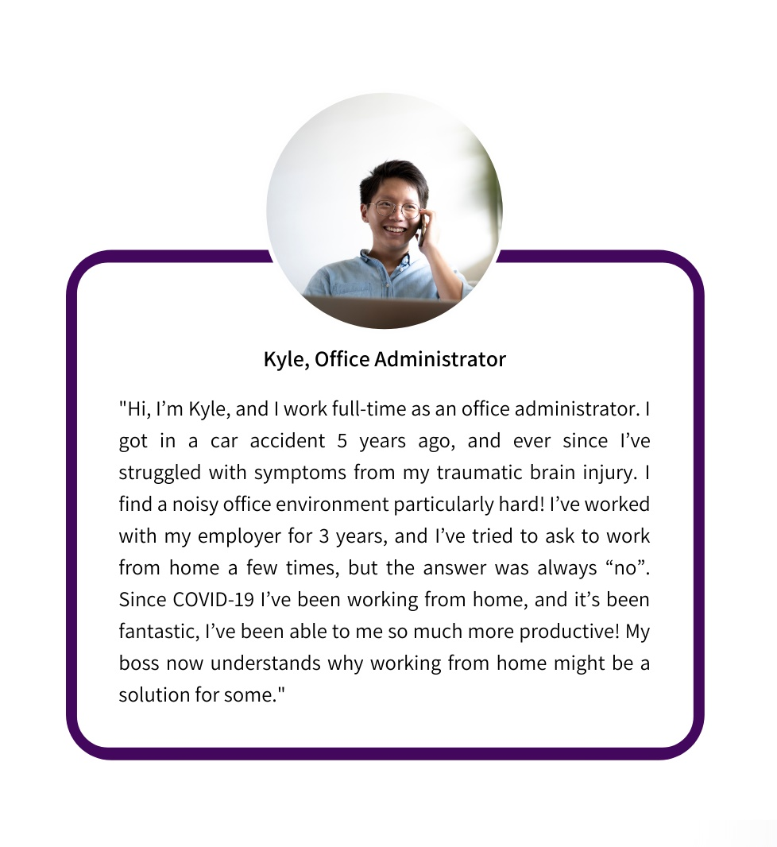

Myths
- Persons with disabilities are less competent in the workplace.
- Persons with disabilities are more costly to employ.
- Persons with disabilities are more likely to be absent from work.
Winning Solutions
1. Employers hire employees based on who is best suited for the job. If an employee is struggling, the disability isn’t the barrier, the environment is.
2. Most accommodations are extremely low cost if not free – think flextime, adjusting job duties, and so on. As well, the small cost for accommodation seems insignificant compared to the cost of rehiring and training a brand-new employee.
3. Absences do not necessarily mean less productivity or effectiveness. Further, strong accommodations can even mitigate the potential effects of absences, boosting your employee’s performance regardless of occasional absences.
Wondering how you can deepen your understanding of this play?
Check out CCRW’s AIM Workshop on “Discussing Disability.”
- Are you ready: Prepare
The highlights:
-Develop an accommodation policy
-Identify your key players
-Train your key players
-Design quick approval guidelines
Organizations have different starting points to begin their journey of improving their accommodation process. With consistent iteration, all businesses can improve. However, we can't expect them to 'do'; before they know what they are aiming for.
Develop an accommodation policy: A crucial step is to develop a clear and effective accommodation policy that communicates your commitment to accessibility and describes how employee's requests are dealt with ⁸. Businesses must also put in the leg work and time to develop policy that caters to your unique circumstances. Areas to consider while creating your policy:
- Commitment to accessibility
- Scope of application
- Definitions
- Responsibilities and expectations
- Procedure for accommodations
- Appeal/complaint process
- Confidentiality
- Reviewing accommodations

Disability Confidence with Marco Pasqua
Set the tone at the top: Whether you’re a small, medium or large-size business, work with your leadership team to set a top-down commitment and vision for an accessible and inclusive workplace using strategies and policies. Showcase your inclusive strategy and approach on your website and public-facing materials.

Identify key players: One of the most important relationships for employees is with their direct manager²⁸. This individual sees them daily and has the most in-depth understanding of their needs and working environment. As managers typically complete most accommodation requests, strengthening this relationship is a fundamental dimension of a solid accommodation practice. In large organizations or with particularly intricate accommodations, additional players such as Human Resources representatives or accessibility consultants may be involved.
Train your key players: it is imperative that managers are equipped to support requests for accommodations. One foundational concept that should underpin the accommodation process is intersectionality. Individuals that are living at the intersections of oppression and exclusion have long faced medical distrust of healthcare providers due to legacy of discrimination. By developing a de-medicalized accommodation process, you can remove the medical aspect that is often a central aspect of the accommodations. Of equal importance is employing a cross-disability lens, which supports people with all types of disabilities, whether visible or invisible. This ensures that people with less common or less visible disabilities, who frequently face intersecting forms of oppression, receive accommodations.
Conversations about accommodation and disability can often be uncomfortable for you and for your employee. Mutual respect and open, honest communication between the employer and the employee are essential for successfully executing accommodations²⁹. The key is reducing this tension and making it into a collaborative conversation that validates an employee’s concerns. This idea is presented in the business classic, "Difficult Conversations: How To Discuss What Matters Most." These learning conversations should take place in a quiet, confidential setting and focus on:
- Accepting and supporting an employee
- Actively listening to an employee’s perspective, rather than seeking evidence to justify an accommodation
- Creating space to understand an employee’s feelings and how their request for accommodation might impact their position and identity in the workplace
True leaders champion diversity and inclusivity in everything they do – they celebrate differences and empower employees to be their best selves at work. This paradigm shift can have powerful impacts and fuel engagement across your workforce as employees feel cared about, heard, and respected.
Design quick approval guidelines: Accommodations can be low-cost and have straightforward solutions. In these circumstances, it is critical that managers have as many ways to say yes to as many requests as possible. A central tool in this pursuit is developing a system of quick approval guidelines. These guidelines will enable managers to approve and implement accommodations that do not require large funds or serious modifications to scheduling or workplace tasks. To establish these guidelines, ask yourself:
- At what level of cost does an accommodation require further oversight? Is there a cost threshold under which a direct manager can simply approve requests?
- At what point does a change in roles and responsibility require additional oversight?
Not only do quick approval guidelines support the autonomy of frontline managers, but accommodations are also efficiently granted - helping employees get back on track. Managers are empowered to take on direct oversight for monitoring and modifying the accommodation going forward.

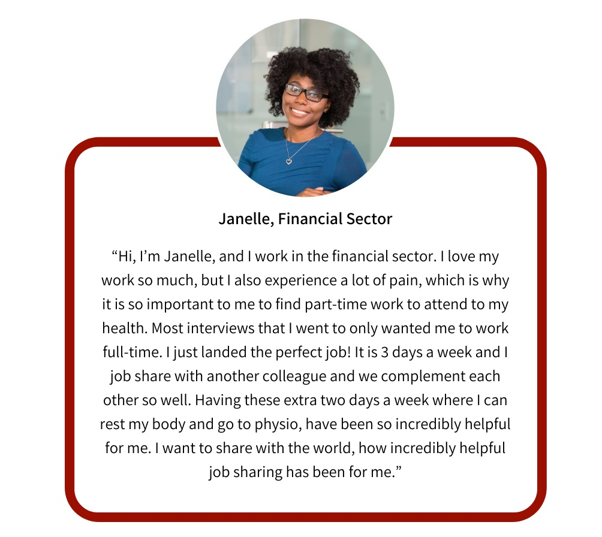

Common Challenges
- I don't know what to put as an accommodation policy.
- I can't do it all on my own.
- I am not comfortable talking about disability and don't want to do it on my own.
Winning Solutions
- Start small, with a strong and clear commitment to accommodation. Then, build out with some excellent public resources offered online.
- Know your capacity. While quick approval guidelines are a powerful tool, acknowledge when you need to ask for assistance from colleagues and consult expert.
- As a rule of thumb, use person-first language and always ask your employee with a disability if you are unsure of what to do or say. Educate yourself through disability awareness training.
Wondering how you can deepen your understanding of this play?
Check out CCRW’s AIM Workshop on “Managing and Disclosure and Accommodation.”
3 Go the Distance: Identify a Process
The highlights:
-Participate in good faith
-Identify workplace barriers and accommodations
-Collaborate, communicate, and decide on accommodations
-Create and implement your plan
An employee may request an accommodation informally or formally, orally, in writing, or by submitting a specific form as required by your accommodation policy. Regardless of the method, as soon as a need for an accommodation is known, the accommodation process is activated. It’s time to ready your tools – consider searching for an accommodation template to document the process, in concert with applying the following play.
Participate in good faith: A simple and guiding principle to set the precedent for successful accommodation is to demonstrate good faith engagement. In today’s business environment, employers need to go beyond legal compliance and the duty to ‘reasonably accommodate’³⁰. For instance, asking for medical information related to disability can weaken the rapport you have built with employees, and send signals to them and their colleagues that discourage disclosure⁷. Moving away from a process initiated with medical evidence is a significant transformation for many, and may take time and persistence.
Identify workplace barriers and accommodations: It is essential to start with engaging in a dialogue with your employee – this is your opportunity to take notes, ask questions, and really understand what your employee is struggling with. While an employee has no legal obligation to disclose their disability, they are the expert in the situation. They know what their needs are, can offer relevant information to facilitate the accommodation process, and can provide valuable suggestions for potential solutions.
Sometimes, you may need to prompt or assist your employee in identifying barriers. A useful tool to get the ball rolling is reviewing the employee’s essential job duties and core functions together³¹. Then, you can pinpoint specific tasks or environmental factors that may present challenges to their success.
With this in mind, craft a list of potentially viable accommodations, such as an ergonomic work from home workspace, accessible technology, noise cancelling headphones, musculoskeletal, and health and well-being models.
If you encounter a roadblock at this stage, remember that you can seek further support and advice from your Human Resources department or external experts like CCRW’s AIM services. While managers have a central role in determining accommodations, input from trained experts may make the process more efficient and comfortable for everyone^{4.}
Disability Confidence with Marco Pasqua
Every team member has different needs. Providing accommodations like desks that are adjustable in height, task lighting for those who may have low-vision or specialized software to assist in job duties often costs very little, but can have a big impact on productivity. With more employees now working from home, many of them already have their space set up the way they prefer, so these accommodations will cost little to no money. When in doubt, ask your colleague directly how you can best assist them.

Collaborate, communicate, and decide on accommodations: If an employee is approving, accommodation decisions can include union representatives and an individual from Human Resources. As much as possible, let the employee lead the conversation. If a direct request has been made for a specific accommodation, use your insight and the information you have gathered to discuss whether it is the best solution for the employee.
In certain instances, requests may not be feasible and that is entirely okay. Recognize that it is your responsibility to find a reasonable accommodation - the ‘perfect solution’ may not be realistic for every employee. However, should you suggest an alternative accommodation, be sure to engage in a learning conversation with your employee to gauge how they feel about it.
Create and implement your plan: Continue the documentation process and devise an structured accommodation plan to present to your employee for review³¹. The goal here is to achieve buy-in – if you haven’t satisfied their request or properly addressed their needs with your plan, they will let you know. If you are in this position, encourage your employee to voice their reasoning for why the accommodation does not meet their needs.
When you do reach consensus, some key factors for effective accommodation roll-out are timeliness, transparency, and diligence. Make clear when accommodations will be implemented, keep your employee informed of the status of the accommodation, and do your due diligence to communicate with the group who will be accountable to procure, install and test an accommodation (i.e., compatibility with your company’s networks and policies). To help you succeed, consider incorporating timing guidelines in your accommodation policy. This will ensure that you implement accommodations in a timely manner and limit the impact that lack of responsiveness can have on the wellbeing of employees. Tangible business impacts, such as greater productivity and increased focus, can multiply quickly through the timely provision of a service need.

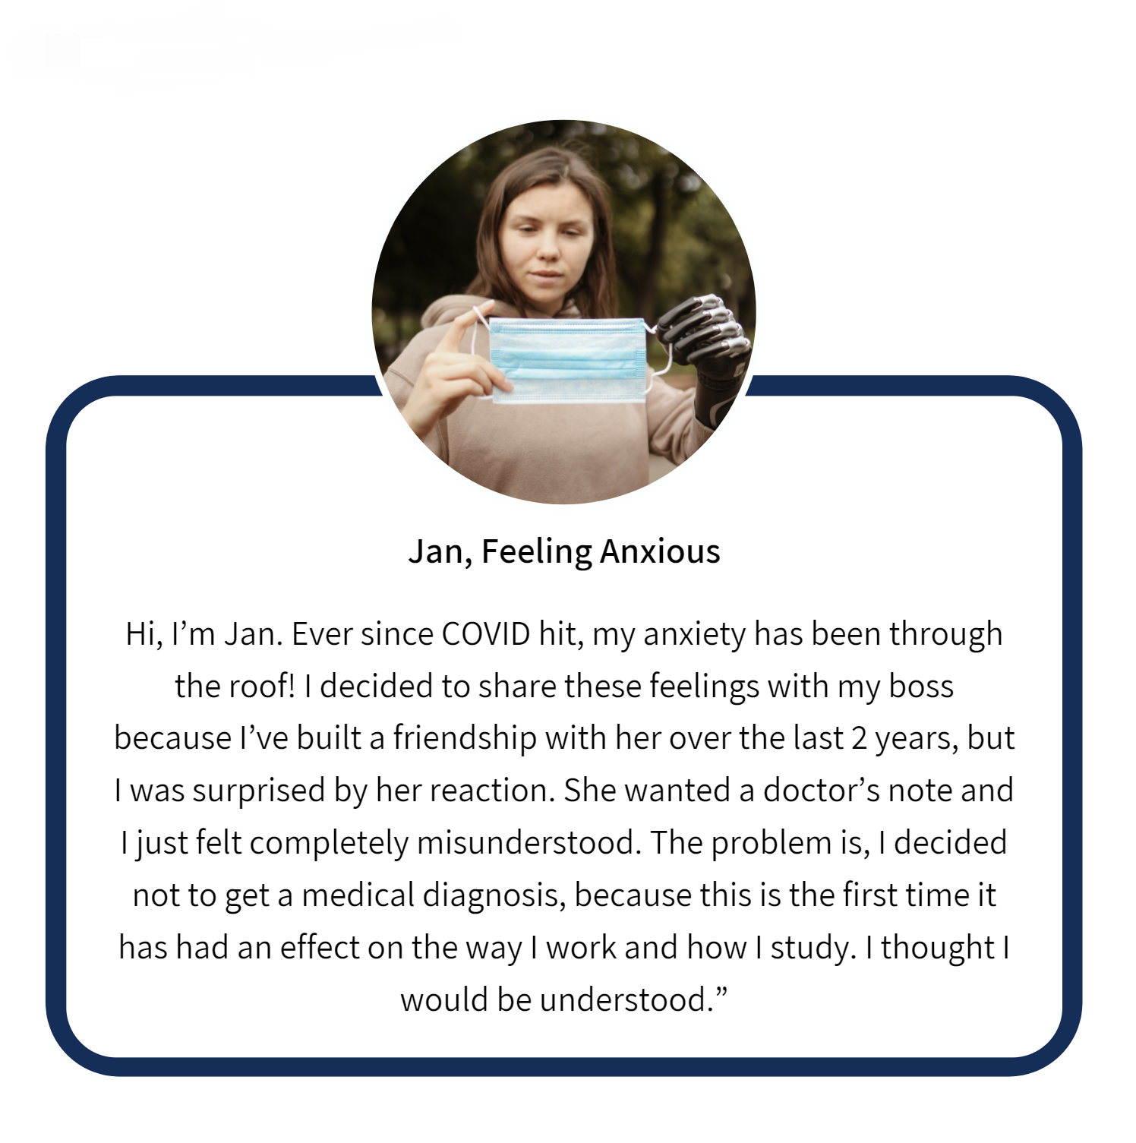

Common Challenges
- Discrimination complaints can be filed if you refuse accommodation and undue hardship is not evident.
- Disorganization among procuring, installing, and testing an accommodation.
- Failing to identify opportunities to inquire about accommodations, even if a request is not made.
Winning Solutions
- Establish a clear accommodation process in your accommodation policy. Adopt a collaborative approach to the accommodation process and practice ongoing dialogue and documentation.
- Engage in communication with all involved parties at every step of the way, to ensure everyone is on the same page.
- Develop an inclusive workplace where casual check-ins with employees are regular and accommodation is rooted in flexibility and adaptability.
Wondering how you can deepen your understanding of this play?
Check out CCRW’s AIM Framework for further context and information.
4 Hit Your Target – Review, Evaluate, Evolve
The highlights:
-Anticipate barriers and provide solutions
-Have an early conversation and review
-Evaluate your accommodation approach
-Evolve over time
The completion of an accommodation is a natural point to consider in your overall accommodation approach. Whether this is the first accommodation your business has completed or one of many, it provides the opportunity to review, evaluate, and evolve your process. Normalization of accommodation, from the earliest interactions, with your organization is both an attainable and a worthwhile goal.
Anticipate barriers and provide solutions: Thinking of potential barriers related to a position before they happen can go a long way towards creating a healthy workplace. For instance, imagine if essential duties and potential obstacles to those duties' performance could be incorporated into the contract an employee signs and be discussed at onboarding. Taking it a step further, you could even develop a checklist of pre-approved accommodations that are available to support your employee, mapped on to each of the functional tasks of a specific job. With this approach, you and your organization become proactive – allowing you to anticipate and provide solutions to your employees' needs and connect to a larger pool of future employees.

Disability Confidence with Marco Pasqua
Review Your Hiring Policies and Job Application Process: Do you have a Diversity and Inclusion Statement? Are your job applications accessible to screen readers? These are just a few things to consider when creating inclusive job postings. Review your postings to ensure they are not unintentionally screening out a person with a disability just by the language you’re using.

Have early conversations and review: During onboarding, it is essential to begin your learning conversations with employees to strengthen rapport. These early engagements can help create an atmosphere that celebrates diversity and inclusion, where new employees feel safe providing accommodation-related information at the beginning of their employment. From the first interactions with your staff, you will sow goodwill and they will see your commitment to accessibility.
Additionally, having knowledge of potential obstacles will significantly help you support your employee(s), as you can schedule regular follow-ups and be prepared with ready-made solutions in advance. Not only does this take the onus away from the employee to request a new or change in of accommodation, but it relies less on an individual manager's memory to check-in and their potential inclination to avoid it. This will also reduce any stress associated with stepping forward to disclose a disability or barrier in the future.
Evaluate your accommodation approach: Once these elements of an ongoing accommodation process are in place, it is critical to have some means to evaluate effectiveness. Assessing the result of a single accommodation allows for later follow-up with the employee and generates data to analyze your overall accommodation approach.
Although this measurement practice can go more in-depth, a good starting point is to track the fundamental dimensions of:
- Time: The amount of time from the start of an accommodation to its implementation.
- Cost: The total cost of the accommodation and resources required to implement
- Benefit: The benefits of the accommodation for the employee and the organization
These three dimensions form the foundation of an evaluation strategy and can even dispel myths that workplace adjustments are costly and do not deliver bottom line impact to your business. We recommend that you determine other key performance indicators (KPIs). In most cases, this will show that the investments made in developing accommodations for employees are compensated for through the increased output and wellness of those employees. If your business can measure KPI changes before and after an accommodation, it is additionally valuable.
Evolve over time: Accommodations are not one-size-fits-all! Updating and expanding a checklist that connects potential accommodations to aspects of a job, rather than an employee, is a task that is worth your organization's time. With routine follow-up after accommodation and examination of KPIs, you can further identify whether an alteration to an existing accommodation is required.
Ultimately, an accommodation policy aims to foster a workplace culture where comfort in disclosing a disability – or even just a workplace barrier – is normalized from the job interview forward. Although accommodation is just one component of an inclusive workplace, adopting the right approach can help you retain talent and increase productivity, putting you leaps and bounds ahead of other businesses.

“Before I met CCRW I was always apprehensive when addressing someone with a disability in the fear of upsetting the individual or not using the correct terminology. After working with CCRW they have eased my concerns by providing educational awareness pieces and offered disability awareness training. It is important for me as the director of culture to promote an equal work force. I would implore any employers to engage with CCRW to find out about their services”
Derek McWilliam,
Director of Culture, Saskatoon Soccer Centre

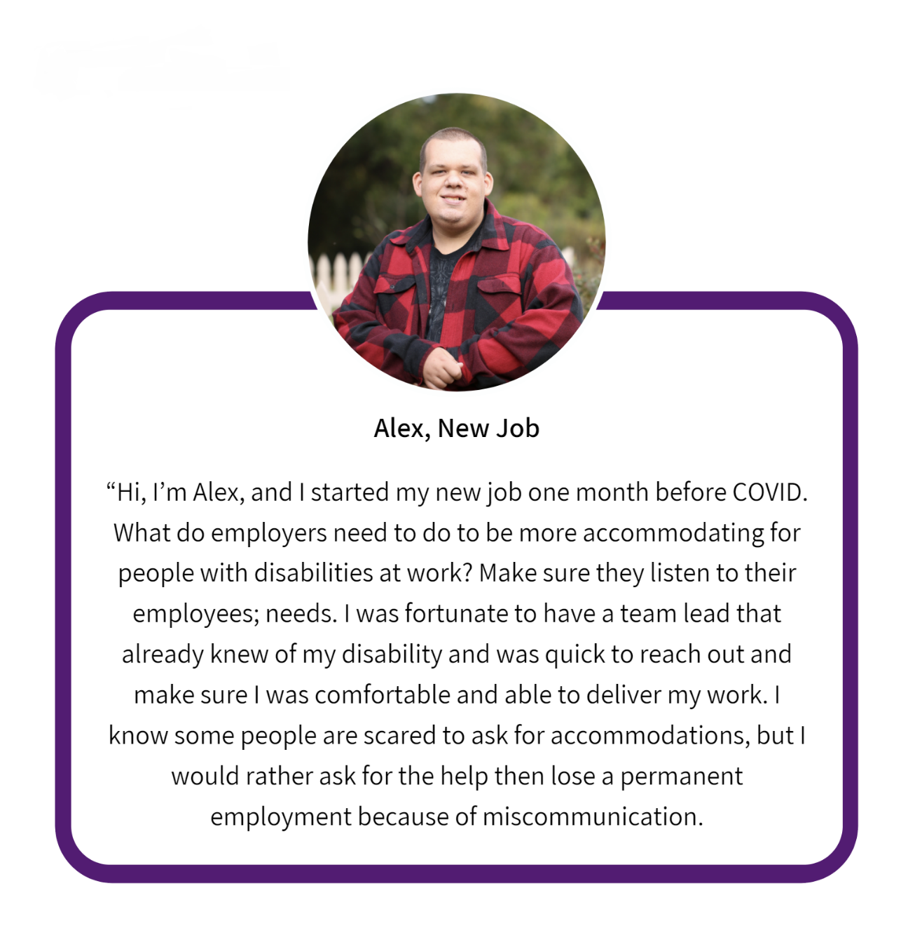

Common Challenges
1. Employees are afraid to request accommodations.
2. The assumption that once an accommodation is implemented, no other modifications are required.
3. Feeling overwhelmed by staying on top of accommodations.
Winning Solutions
- From the onset of an employee’s journey, meet them with trust and openness and make clear your commitment to accessibility.
- People, their needs, and their environments constantly change (think COVID-19). If something isn’t working, rework the accommodation and make adjustments as needed.
- Normalize ongoing meetings with employees and leverage them as opportunities to pro-actively discuss your employees’ needs.
Wondering how you can deepen your understanding of this play?
Check out the AIM framework within the AIM suite of services.
5 The ball is in your court: Build your disability confidence
The highlights:
-Engage your leaders
-Create impact among colleagues
-Move the disability confidence needle (or move the needle)
Picture this – as you have walked through plays 1-4, you have reimagined disability, developed an accommodation policy, and learned about how to collaborate and employees with disabilities to successfully tackle accommodations. In the process, your understanding, capacity, and disability-related skills have been sharpened. With this momentum, you are well on your way to becoming a disability confident manager. While accommodation is just one stop in the employee’s life-cycle, mastering this process fosters an inclusive workplace culture, this can help you attract a larger talent pool and retain highly skilled employees living with disability.
Disability Confidence with Marco Pasqua
Having a diverse workforce, one that includes people with disabilities, can actually positively impact your bottom-line and some of your competitors might already be one step ahead of you. Companies like Microsoft, SAP and the Vancouver Airport recognize the business case for building disability confidence.

Engage your leaders: The next step is to take it broader – build a community of individuals who can act as champions of inclusion and present your ideas to your company leaders. Reach out to important leaders who can support your vision, such as a Diversity and Inclusion Coordinator or an Accessibility Officer. Develop a working group and a strategic plan to show your C-Suite why disability confidence is a business imperative.
Create impact among colleagues: The movement does not stop there, “The only limit to your impact is your imagination and commitment” – Tony Robbins. As a manager who recognizes accommodation as a business solution, you need to get your employees on board as well. Persons with disabilities who consider disclosure can be met with real risks, such as stereotyping, ignorance, and discrimination among co-workers³². Co-worker reactions to accommodation can be sometimes negative (i.e., resenting the employee with the disability, and perceiving accommodations to be unjust^{18,33}). Therefore, it is crucial to empower your employees to fuel the change as well. Help your employees understand that accommodations, and disability confidence, are a path to an enhanced workforce. By leveraging accessibility as an asset, you can support employee productivity and thus, performance within your organization, leading to a healthier and more inclusive workplace.
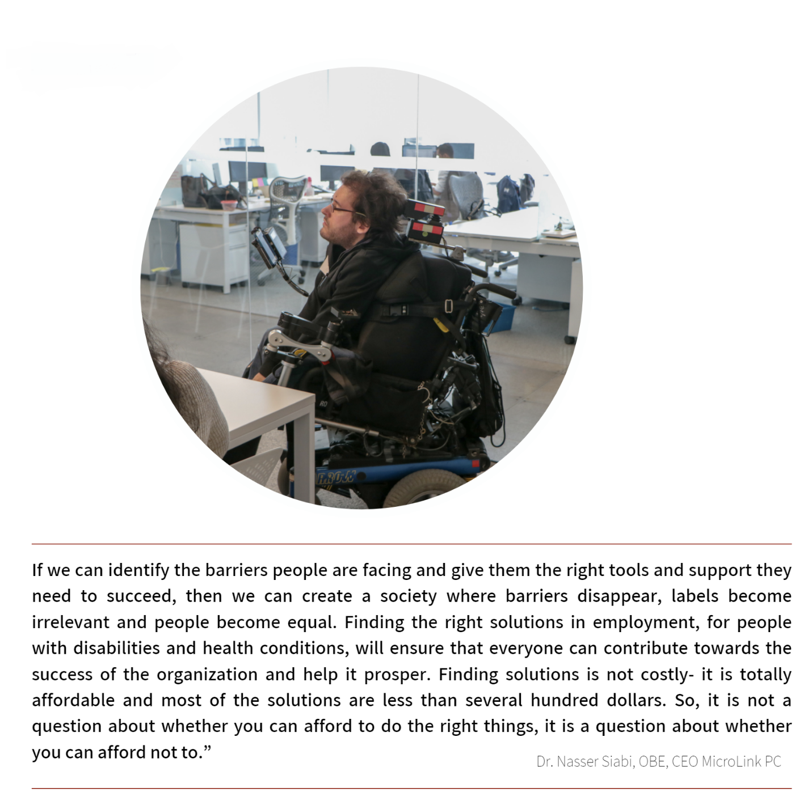
Move the needle: While the COVID-19 pandemic has sparked a multitude of challenges for persons with disabilities, it has forced employers to pivot, embrace flexibility, and innovate. We have witnessed a rapid transition to remote work, and this accommodation has reaped benefits for employees with and without disabilities alike. Keeping in stride, the pandemic presents an opportunity for you to revolutionize your approach to inclusion and commit to disability confidence³⁴. The future of work is now, and the business case for realizing the potential of persons with disabilities is undeniable.
Are you ready?

Common Challenges
1.I don’t have the support I need to move this forward in my company.
2.Nobody in my industry is focusing on this.
3.How will I ever become disability confident?
Winning Solutions
- Educate your colleagues, as best as you can, and lead by example.
- Do your research and unpack the business and ethical rationale for disability confidence.
- Embrace the moving target and understand that disability confidence grows over time.
Wondering how you can deepen your understanding of this play? Check out CCRW’s AIM Workshop entitled “Beyond Accessibility.”

Moving Forward
Marco Pasqua, Accessibility Consultant
Over the past year, we’ve learned a lot when it comes to making adjustments in where and how we work. Technology has enabled us to stay connected with friends and co-workers. It has also revealed how it can be utilized to improve accessibility and inclusion and develop disability confidence within our organizations without the typical barriers experienced by many with disabilities. Prior to COVID, there were some incredible achievements in the areas of diversity and inclusion; with the introduction of the first-ever Accessible Canada Act 10 . Although this will initially only impact federally-run organizations and services, it’s an opportunity for all businesses to reflect on how they can be more inclusive – not just in the physical spaces in which we work, but also, how we go about hiring individuals, the accommodations we provide and the overall culture we create.
Jamie Burton, Chief Business Development Officer,
What we do here matters. It requires fostering a trusted environment for open & honest discourse. A workplace without fear that someone will object to a difference in thinking, perspective, or required work adjustments. The challenge is in how we interact, respond and respect each other. Whether some disclose or identify specifically, and others do not is immaterial to our work responsibilities. Our collective responsibility is to ensure we emulate the behaviour we hope to see in others, and we construct the best standard of accommodation management to make it possible for others to recognize their role within. Together with the strengths of our differences & unique perspectives with inclusion of people with disabilities, we will achieve our greatest potential.
CCRW is responsive to both the needs of job seekers with disabilities
and the businesses seeking diverse talent.
Stay tuned.

Stay Connected

Website
www.CCRW.org/AIM
Email
AIM@ccrw.org
Contact number
1 (800) 664-0925 ext. 384

Instagram
Twitter
Facebook
LinkedIn

References
1. Canadian Federation of Independent Business. COVID-19: State of Small Business. 2021. Accessed March 18, 2021. https://www.cfib-fcei.ca/en/covid-19-surveys
2. Lindsay S, Cagliostro E, Leck J, Shen W, Stinson J. Employers’ perspectives of including young people with disabilities in them workforce, disability disclosure and providing accommodations. Journal of Vocational Rehabilitation. 2019;50(2).doi:10.3233/JVR-180996
3. Prince MJ. Persons with invisible disabilities and workplace accommodation: Findings from a scoping literature review. Journal of Vocational Rehabilitation. 2017;46(1). doi:10.3233/JVR-160844
4. The Office of the Public Service Accessibility. 2020 Validation of Key Findings from the 2019 Treasury Board of Canada Secretariat Benchmarking Study of Workplace Accommodations in the Federal Public Service. 2020. Accessed March 18, 2021. https://www.canada.ca/en/government/publicservice/wellness-inclusion-diversity-public-service/diversity-inclusion-public-service/accessibility-public-service/benchmarking-study-workplace-accommodations/2019-tbs-benchmarking-study-workplace-accommodations-federal-public-service-validation-key-findings.html
5. Tompa E, Buettgen A, Mahood Q, Padkapayeva K, Posen A., Yazdani A. Evidence Synthesis of Workplace Accommodation Policies and Practices for Persons with Visible Disabilities: Final Report.
6. Schur L, Nishii L, Adya M, Kruse D, Bruyère SM, Blanck P. Accommodating employees with and without disabilities. Human Resource Management. 2014;53(4). doi:10.1002/hrm.21607
7. Gignac MAM, Bowring J, Jetha A, et al. Disclosure, Privacy and Workplace Accommodation of Episodic Disabilities: Organizational Perspectives on Disability Communication-Support Processes to Sustain Employment. Journal of Occupational Rehabilitation. Published online 2020.doi:10.1007/s10926-020-09901-2
8. Erickson WA, von Schrader S, Bruyère SM, VanLooy SA. The Employment Environment: Employer Perspectives, Policies, and Practices Regarding the Employment of Persons With Disabilities. Rehabilitation Counseling Bulletin. 2014;57(4).doi:10.1177/0034355213509841
9. Padkapayeva K, Posen A, Yazdani A, Buettgen A, Mahood Q, Tompa E. Workplace accommodations for persons with physical disabilities: evidence synthesis of the peer-reviewed literature. Disability and Rehabilitation. 2017;39(21).doi:10.1080/09638288.2016.1224276
10. Accessible Canada Act. SC 2019, c 10.
11. United Nations, Department of Public Information. Convention on the Rights of Persons with Disabilities. 2006. Accessed March 18, 2021. https://www.un.org/development/desa/disabilities/convention-on-the-rights-of-persons-with-disabilities.html
12. Syma C. Invisible disabilities: perceptions and barriers to reasonable accommodations in the workplace. Library Management. 2019;40(1-2). doi:10.1108/LM-10-2017-0101
13. Schartz HA, Hendricks DJ, Blanck P. Workplace accommodations: Evidence based outcomes. Work. 2006;27(4).
14. Solovieva TI, Dowler DL, Walls RT. Employer benefits from making workplace accommodations. Disability and Health Journal.2011;4(1). doi:10.1016/j.dhjo.2010.03.001
15. Morris S, Fawcett G, Brisebois L, Hughes J. A Demographic, Employment and Income Profile of Canadians with Disabilities Aged 15 Years and over, 2017.; 2018.
16. Shaw LR, Chan F, McMahon BT. Intersectionality and disability harassment: The interactive effects of disability, race, age, and gender. Rehabilitation Counseling Bulletin. 2012;55(2). doi:10.1177/0034355211431167
17. Brown RL, Moloney ME. Intersectionality, Work, and Well-Being: The Effects of Gender and Disability. Gender and Society. 2019;33(1). doi:10.1177/089124321880063623
18. Bonaccio S, Connelly CE, Gellatly IR, Jetha A, Martin Ginis KA. The Participation of People with Disabilities in the Workplace Across the Employment Cycle: Employer Concerns and Research Evidence. Journal of Business and Psychology. 2020;35(2).doi:10.1007/s10869-018-9602-5
19. Louvet E. Social Judgment Toward Job Applicants With Disabilities: Perception of Personal Qualities and Competences. Rehabilitation Psychology. 2007;52(3). doi:10.1037/0090-5550.52.3.297
20. Schur L, Kruse D, Blanck P. Corporate culture and the employment of persons with disabilities. Behavioral Sciences and the Law.2005;23(1). doi:10.1002/bsl.624
21. Burke J, Bezyak J, Fraser RT, Pete J, Ditchman N, Chan F. Employers’ Attitudes Towards Hiring and Retaining People with Disabilities: A Review of the Literature. Australian Journal of Rehabilitation Counselling. 2013;19(1). doi:10.1017/jrc.2013.2
22. Spirito Dalgin R, Bellini J. Invisible disability disclosure in an employment interview: Impact on employers’ hiring decisions and views of employability. Rehabilitation Counseling Bulletin. 2008;52(1). doi:10.1177/0034355207311311
23. Benoit C, Jansson M, Jansenberger M, Phillips R. Disability stigmatization as a barrier to employment equity for legally-blind Canadians. Disability and Society. 2013;28(7). doi:10.1080/09687599.2012.741518
24. Till M, Leonard T, Yeung S, Nicholls G. A Profile of the Labour Market Experiences of Adults with Disabilities among Canadians aged 15 years and older, 2012. Statistics Canada. 2015;(89).
25. Novak JA, Rogan PM. Social integration in employment settings: Application of intergroup contact theory. Intellectual and Developmental Disabilities. 2010;48(1). doi:10.1352/1934-9556-48.1.31
26. Carvalho-Freitas MN de, Stathi S. Reducing workplace bias toward people with disabilities with the use of imagined contact. Journal of Applied Social Psychology. 2017;47(5). doi:10.1111/jasp.12435
27. Phillips BN, Deiches J, Morrison B, Chan F, Bezyak JL. Disability Diversity Training in the Workplace: Systematic Review and Future Directions. Journal of Occupational Rehabilitation. 2016;26(3). doi:10.1007/s10926-015-9612-3
28. Shaw WS, Robertson MM, Pransky G, McLellan RK. Employee perspectives on the role of supervisors to prevent workplace disability after injuries. Journal of Occupational Rehabilitation. 2003;13(3). doi:10.1023/A:1024997000505
29. Gold PB, Oire SN, Fabian ES, Wewiorski NJ. Negotiating reasonable workplace accommodations: Perspectives of employers, employees with disabilities, and rehabilitation service providers. Journal of Vocational Rehabilitation. 2012;37(1).doi:10.3233/JVR-2012-0597
30. Brown S, Scott-Parker S. The Disability-Confident Employers’ Toolkit. 2020. Accessed March 18, 2021. https://inclusivefutures.org/disability-confident-employers-toolkit/
31. MacDonald-Wilson KL, Fabian E, Dong SL. Best practices in developing accommodations in the workplace: Findings based on the research literature. The Rehabilitation Professional. 2008;16(4).
32. Vornholt K, Uitdewilligen S, Nijhuis FJN. Factors affecting the acceptance of people with disabilities at work: A literature review. Journal of Occupational Rehabilitation. 2013;23(4). doi:10.1007/s10926-013-9426-0
33. Colella AJ, Bruyère SM. Disability and employment: New directions for industrial and organizational psychology. In: APA Handbook of Industrial and Organizational Psychology, Vol 1: Building and Developing the Organization. ; 2010.doi:10.1037/12169-015
34. Jesus TS, Landry MD, Jacobs K. A “new normal” following COVID-19 and the economic crisis: Using systems thinking to identify challenges and opportunities in disability, telework, and rehabilitation. Work. 2020;67(1). doi:10.3233/WOR-203250

