

Disability and Work in Canada 2024
Speaker Biographies

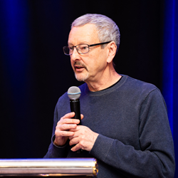 | Alec Farquhar,  Co-Lead, Engagement, Inclusive Design for Employment Access  Alec Farquhar is a lawyer and currently Co-Lead, Engagement, for Inclusive Design for Employment Access – Social Innovation Laboratory and a member of the steering committee for Disability and Work Canada. Previously, Alec was Director of the Office of the Worker Adviser (OWA), an agency of the Ontario Ministry of Labour, Immigration, Training and Skills Development (MLITSD) which provides advice and representation to thousands of injured workers annually. Alec came to the OWA from the Occupational Health Clinics for Ontario Workers where he was Managing Director, and before that from the MLITSD where he was the Director of the Occupational Health and Safety Branch. Alec has extensive experience in both workers' compensation and occupational health and safety. He has a long history of working with vulnerable worker communities including immigrant workers, women and young workers. He has also worked extensively on partnerships with the employer community around dispute resolution, health and safety and employment and the employment and inclusion of workers with disabilities. This includes innovative joint return to work partnerships of unions and employers in large workplaces. Alec is a member of the Executive of the Ontario Bar Association’s Workers’ Compensation Section. He is fluent in Italian and French which has helped him connect directly with the francophone and Italian-Canadian communities. A graduate of Princeton University, Alec has an L.L.B. from the University of Toronto Faculty of Law.
 | Alexia Ostrolenk  CIHR Health System Impact Postdoctoral fellow, Autism Alliance of Canada  Alexia Ostrolenk (she/her) is a postdoctoral fellow at Autism Alliance of Canada in partnership with Unity Health Toronto, supported by a Canadian Institutes of Health Research’s Health System Impact Fellowship award. She completed her PhD in Psychiatric Science at Université de Montréal focusing on reading and language development in Autistic children. Her current work consists in reviewing the services available to Autistic people in Canada and improving their access to employment.
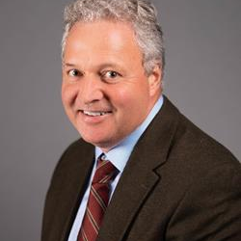 | Alfred McLeod  Assistant Deputy Minister of Public Service Accessibility at Treasury Board of Canada Secretariat, Government of Canada  Alfred MacLeod was appointed to the position of Assistant Deputy Minister of Public Service Accessibility at Treasury Board of Canada Secretariat in October 2018.  From 2017 to 2018, Alfred was Assistant Deputy Minister at Public Services and Procurement Canada, where he oversaw the Canada Post Corporation Review.  Previously, Alfred was Assistant Deputy Minister of PSPC’s Policy, Planning and Communications Branch. Other experience includes a 2-year Executive Interchange with CBC/Radio-Canada as Executive Director of Corporate Affairs, as well as previous Assistant Deputy Minister positions at the Privy Council Office and Citizenship and Immigration Canada. Before joining the federal public service, Alfred was Senior Vice-President, Public Policy, at EKOS Research Associates Inc.  Alfred holds bachelor’s degrees in History and Education from Acadia University, and a MPhil (Politics) from the University of Exeter. He is a graduate of the Australia and New Zealand School of Government’s Executive Fellows Program.
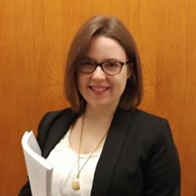 | Alicha Keddy  Analyst at the Office of Public Service Accessibility, Treasury Board Secretariat, Government of Canada  Alicha Keddy earned her PhD in English Language and Literature in 2020, with a specialization in feminist modernism and intersectional studies. With over a decade of experience in intersectional research and analysis, she is deeply committed to advancing equity and inclusion. Since joining the Public Service in 2021, Alicha has been leveraging her expertise in the field of accessibility policy.
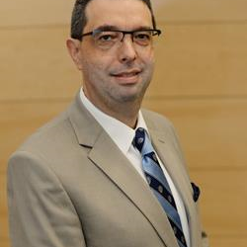 | André Baril  Director General of Accessibility and Disability Inclusion Projects in the Office of the Deputy Minister Champion for Federal Employees with Disabilities, Government of Canada  André has over 25 years of experience in policy and operations in the Government of Canada. From 2022 to 2024, he was Director General of Aviation Security at Transport Canada. Prior to this role, he held various executive positions at Immigration, Refugees and Citizenship Canada (IRCC). Over the past 5 years, he supported the restart of the aviation system and the decongestion of airports, led the establishment of Verified Traveller lines at major airports, the re-engineering of immigration services in response to COVID, COVID border restrictions and exemptions, and he coordinated IRCC’s efforts in evacuations out of Afghanistan during the air bridge closure.  André is visually impaired and is a federal employee with lived experience as a person with disability. From 2017 to 2024, he was Chair and Champion of IRCC’s and Transport Canada’s networks for persons with disabilities.  He has a master’s degree in Economics from the University of Toronto and a bachelor’s degree in Economics from Université de Montréal (with a one-year exchange at the University of British Columbia). He is passionate about disability inclusion and is a proud father of three sons.
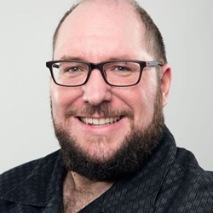 | Andy Livingston  Research Consultant, CNIB  Andy is a community-minded consultant and dispute resolution specialist based out of Saskatoon, Saskatchewan, Canada. With more than a decade of experience working as a human rights investigator, Andy is also a designated National Qualified Mediator and Qualified Arbitrator. He has a passion for helping people find meaningful and successful resolutions to conflict outside of the courtroom. Andy continues to pursue new professional development opportunities, such as online dispute resolution, to hone his skills and knowledge. He also holds a Community Mental Health Certificate from Herzing College and a Rick Hansen Foundation Accessibility Certification. Andy is also an individual living with a disability and has more than 10 years working in policy development, helping to make the world more accessible for all. His skill and knowledge in the field is renowned and he is frequently called upon by governments of all levels to consult on policy, legislation and public programs involving people with disabilities.
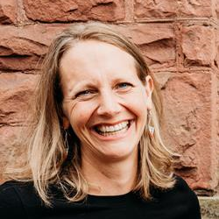 | Anna Nelson  Director of Employment Supports, LiveWorkPlay  Anna is the Director of Employment Supports at LiveWorkPlay. Anna joined LiveWorkPlay in 2017 and, previously, worked in various leadership roles in the developmental services sector in Toronto, Ottawa, and Thunder Bay Ontario. She believes the most critical demonstration of inclusive employment progress is seeing more people with intellectual disabilities and autistic job seekers being hired for meaningful employment and seeing them develop within these jobs. Moving beyond awareness and into action drives her work every day. Mother of two active kids, Anna loves to spend as much time in the woods as possible- x-country skiing, trail running, and canoeing.
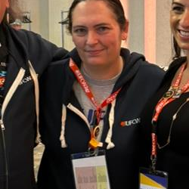 | Ashley Baresinkoff  Deli Clerk and Union Member, UFCW Local 247  Ashley Baresinkoff has been a Long term UFCW Local 247 member and Committee Member for UFCW 247 Engagement Committee and UFCW National Indigenous Committee . Ashley is Neurodivergent and Caregiver to a young child with Autism. As a proud Métis Woman she has been advocating for the intersection of Indigenous and Disability Rights . Earlier this year she became the First Diverse Learners Representatives with Waceya Métis Charter for Métis Nation British Columbia to advocate for Local Supports for Neurodivergent Children , Youth and Adults . She brings her passion for advocacy to her work and helps other navigate the Unionized Spaces around Disability and accommodations . In 2019 Ashley Spearheaded one for the First Sensory Friendly Shopping hours in British Columbia , working side by Side with her Union , her employer and Autism BC to develop a Standard operating procedure to be rolled out to other Grocery Stores across BC .
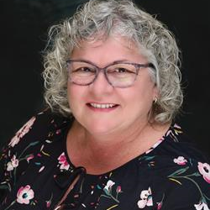 | Beverly Collins  National Secretary-Treasurer, CUPW  Beverly Collins was elected National Secretary-Treasurer at the May 2015 CUPW National Convention. Prior to her election, she held the fulltime position of Secretary-Treasurer of the CUPW Ottawa Local. She was also a member and subsequently President of the CUPW National Board of Trustees. Beverly has extensive knowledge of the collective agreement and in her responsibilities as Secretary-Treasurer, she provided clarification and support to the membership. She also facilitated pension courses. Beverly holds a position of Letter Carrier in her employment with Canada Post.
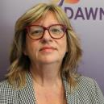 | Bonnie Brayton  Executive Officer Chief, DAWN-RAFH Canada  Bonnie Brayton is the National Executive Director of the DisAbled Women’s Network (DAWN), who recently celebrated 35 years in service Bonnie is a recognized leader in both the feminist and disability movements in Canada and internationally. Ms. Brayton is also a founding member of the Ending Violence Association of Canada and served on the Steering Committee of La Maison Parent-Roback, from 2008-15. Ms. Brayton serves on the Advisory Committee for the Jarislowsky Chair in Families and Work at Live Work Well Research Centre at the University of Guelph. She is also the Partner Liaison for a seven-year initiative based at the University of Guelph called “Engendering Disability-Inclusive Development” (EDID). From 2016 to 2021, Ms. Brayton served as a member of the Federal Minister’s Advisory Council on Gender-Based Violence (WAGE). Bonnie has also contributed to several anthologies including A BOLD VISION and LIVING THE EDGES, a DisAbled Women’s Reader and the newest release (2021) from Inanna publications STILL LIVING THE EDGES.
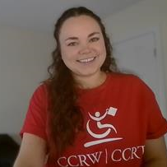 | Brianne Dallas  Digital Adoption Support, CCRW  Brianne has been with CCRW since 2020, supporting job seekers with disabilities in finding and retaining meaningful employment as well as supporting their new employers. Brianne has a wealth of knowledge on the barriers that can exist in the job search process. Brianne has recently stepped into a support role for all of our Employment Coaches across Canada, to assist in the adoption of digital tools to help increase our support.
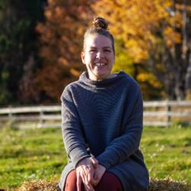 | Chloée C. Godin-Jacques  Lead Researcher, NEADS  Chloée Catherine (she/they | elle/eil) is a white settler disabled queer person. She is currently pursuing a Ph.D in Education at Western University. Chloée is an activist and strives to generate awareness about accessibility, disability, and intersectionality and dismantle preconceived notions by sharing her own diverse lived experiences through the means of blog posts and social media posts. She is also a Lead Consultant at Chloée Catherine Consulting, where she supports businesses and other organizations to further foster inclusive spaces for disabled persons. Chloée’s personal and professional interests lie within the realms of accessibility, activism, community-building, disability, higher education, intersectionality, and sexuality. You can follow Chloée’s journey via @chloeecatherine_ (on Instagram) and chloeecatherine.com
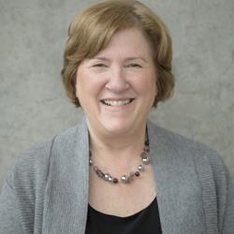 | Doramy Ehling  Chief Executive Officer, Rick Hansen Foundation  As CEO, Doramy Ehling leads the Rick Hansen Foundation (RHF) in its vision to create an inclusive world where people with disabilities are living to their full potential. Prior to her appointment as CEO in December 2018, Doramy held the position of Chief Operating Officer of the Foundation for 11 years and supported the development of several innovations including the Rick Hansen Institute and the RHF Accessibility Certification™ program.  Before joining the Rick Hansen Foundation, Doramy held several positions within the Government of Canada at Canadian Heritage, which included portfolios within Sport Canada, and the Federal Secretariat on the 2010 Olympic and Paralympic Games.  An active volunteer in the sports community over the past 30 years, Doramy is also a member of SSHRC’s Quality in Canada’s Built Environment five-year project, a member of the Ingenium Board of Trustees, the steering committee for the annually held Disability and Work in Canada Conference (DWC), and locally a member of the Greater Vancouver Board of Trade’s Diversity and Inclusion Leadership Council Advisory Committee.
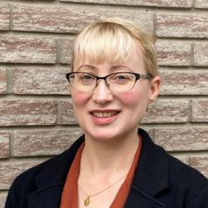 | Elaine Logie  Program Coordinator, The Career Foundation  Elaine Logie has over 15 years experience supporting job seekers with disabilities in finding meaningful employment. She is currently the Program Coordinator for The Career Foundation’s Empowering Abilities Program in Hamilton and is the Founder/Chair for the Hamilton Disability Employment Network (HDEN).
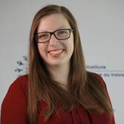 | Elizabeth White  Manager, Programs, Work Wellness Institute  Elizabeth White is the Manager, Programs at the Work Wellness Institute, where she channels her passion for learning and development. With over 10 years of experience in the non-profit sector, Elizabeth is dedicated to creating impactful educational programs that promote workplace inclusivity. She thrives on finding the perfect balance between learning mediums and outcomes to drive forward knowledge mobilization across the organization. Her diverse educational background has honed her ability to blend creativity with strategic thinking. Elizabeth’s love for creating learning resources and her project management skills are evident in her work, where she continuously seeks to make a positive difference every day.
 | Emile Tompa  Executive Director, Inclusive Design for Employment Access  Dr. Emile Tompa is a senior scientist at the Institute for Work & Health. He holds appointments as an Associate Professor in the Department of Economics at McMaster University and as an Assistant Professor at the Dalla Lana School of Public Health at the University of Toronto. He also has an appointment at Pacific Coast University where he is area lead for research and sits on the curriculum and ethics committees. Tompa is Director of the Centre for Research on Work Disability Policy, an eight-year, pan-Canadian initiative funded by a Social Sciences and Humanities Research Council Partnership Grant. Tompa is a labour and health economist with an MBA from the University of British Columbia, an MA in economics from the University of Toronto, and a PhD in economics from McMaster University. Tompa is an associate editor for BMC Public Health, and is on the editorial boards of the Journal of Occupational Rehabilitation and the Scandinavian Journal of Work Environment and Health. He also sits on the National Stakeholder Advisory Panel of the Canadian Labour-Market Information Council. Tompa’s research interests include the consequences of occupational health and safety system design on the health and well-being of individuals and populations, the economic evaluation of workplace interventions for improving the health and well-being of workers, the economic burden of occupational injury and illness, and the analysis of disability policy systems.
 | Emma, Kieftenbeld  Workplace Inclusion Strategist, Gateway Association  Emma Kieftenbeld entered supportive employment after embarking on roles as a respite worker, live-in caregiver, and recreation therapy assistant. Emma has been working with Gateway Association for over 2 years now, specifically, serving youth and young adults. This last year, in partnership with Multicultural Health Brokers, she worked on a pilot project that served newcomers living with barriers to employment to navigate entering the Canadian workforce. Emma has and continues to use her strong passion to support folks from all walks of life to find meaningful community involvement.
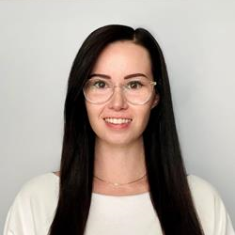 | Emma, Duffy  Workforce Solutions Lead, Sinneave Family Foundation  Emma Duffy (She/Her) is a Workforce Solutions Lead at the Sinneave Family Foundation. She has a Bachelors in Community Rehabilitation & Disability Studies and a Masters in Management, along with 8 years of experience working with non-profits. Emma plays a lead role in ensuring the success of the NEUROinclusive Workforce Solutions service and is passionate about supporting employers and teams in learning more about how to be a neuroinclusive workplace.
 | Emma, Lui  Senior Human Rights Officer, CUPE  Emma Lui is a Senior Human Rights Officer at the Canadian Union of Public Employees. Her focus is disability justice and anti-racism. Emma has worked in social justice and human rights for more than 20 years. She is a member of Biblioterre, a land-based cooperative near Wakefield, Quebec. She has worked in holistic health with a focus on activist burnout, systemic oppression and intergenerational trauma. Emma lives in Gatineau, on Algonquin Anishnaabe territory, with her partner and little one. In her spare time, she loves to read, garden and spend time with family.
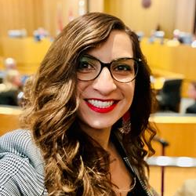 | Emmanuelle Lopez  Human Rights, Equity & Diversity Coordinator, UFCW Canada  Emmanuelle works and plays on territory stewarded by Mississaugas of the Credit First Nation. As UFCW Canada’s National Human Rights, Equity and Diversity Co-ordinator, Emmanuelle leads national equity-focused strategic programming and advocacy initiatives dedicated to building worker power through an anti-oppressive, intersectional and feminist approach. Emmanuelle has a 20+ year track record of representing injured workers, mobilizing anti-ableist strategies and leading activism to strengthen disability inclusion on the job and in society at large. She is a proud member of the Accessible Standards Canada Technical Committee on Employment. She also serves as Chair of the union’s national Human Rights, Equity and Diversity Committee, the UFCW Canada national Indigenous Committee and she is an Executive Committee member of UFCW OUTreach, the union’s 2SLGBTQ+ constituency group.
 | Eppo Maertens  Policy Director, Employment and Social Development Canada (ESDC)  Since 2016, Eppo has been working as a policy director where he is responsible for policy managements of new Workforce Development Agreements (WDA) and the Opportunities Fund for Persons with Disabilities. Eppo led the policy development and implementation of the WDAs, including overseeing the Memorandum to Cabinet and Treasury Board Submission and conducting negotiations with provinces and territories.
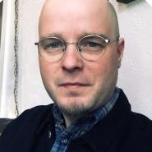 | Evan Wicklund  Manitoba Office Lead and Senior Research Officer, Canadian Centre on Disability Studies (o/a Eviance)  Evan D. Wicklund is a Senior Researcher at the Canadian Centre on Disability Studies (o/a Eviance) and a Ph.D. student in the Sociology and Anthropology Department at Carelton University. He is also an Instructor in the Disability and Community Support Program at Red River College. He has a Master's Degree in Cultural Studies (with a specialization in Texts and Cultures) and a Bachelor of Arts (Honors) Degree in Disability Studies from the University of Winnipeg. He has over ten years of experience working in the disability field in a variety of capacities, including academic and community-based research, advocacy, education, employment, and community living.
 | Genevieve Sauve  Professor, Université du Québec A Montréal (UQAM)  Geneviève Sauvé is an Assistant Professor in the department of education and pedagogy – career counseling at the Université du Québec A Montréal (UQAM) and a Researcher at the Douglas Research Center. Her research focuses on mental health and vocational inclusion.
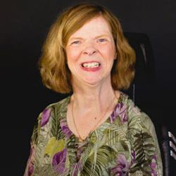 | Glenda Watson Hyatt  MASc student, Queen's University  Glenda Watson Hyatt is perhaps the most prominent and formidable voice advocating for Canadians living with speech disabilities. And, pardon the pun: That’s saying something. Watson Hyatt’s lived experience with cerebral palsy may seem to stand in the way of traditional speech communication. But few people have said as much, nor resonated so broadly than her.  Watson Hyatt refuses to allow those living with speech disabilities to not be heard. As a MASc student at Queen’s University, her research “Recruiting, hiring, and retaining employees with speech disabilities in Canada” attracted partnership with the Canadian Council on Rehabilitation and Work (CCRW)..  Watson Hyatt is a change agent. Her work: pioneering. Her approach: tenacious. Because those with speech disabilities should be heard.  In her role as a communication access advocate, she is an author and, yes, a keynote speaker. And she proves daily that someone with a speech disability still has a powerful voice.
 | Haley Gienow-McConnell  Accessibility Lead, Left Turn Right Turn Ltd.  Haley holds a PhD in History and Disability Studies. She is an experienced researcher with numerous funded research projects and publications. Outside of academia, Haley is a seasoned accessibility specialist with experience serving diverse sectors including academic, government, non-profit, and private. Haley is a skilled project manager with specialties in change management, program evaluation, knowledge translation and transfer, public engagement, and training. She has a background in teaching and curriculum design in post-secondary, adult education, and elementary settings. Haley is active on the conference circuit, frequently delivering presentations and workshops to industry professionals and stakeholders on topics related to disability and accessibility.
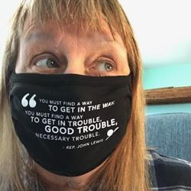 | Heather Walkus  National Chair, Council of Canadians with Disabilities (CCD)  Heather Walkus is honoured to be the National Chairperson of the Council of Canadians with Disabilities (CCD) The only National Human Rights Disability Organization run by people and Organizations representing intersectional and cross disability issues for over 46 years.  A Community Developer, Organizer, and Social Justice Activist with over 5 decades of experience working in social justice intersecting with identity and cross-disability Human Rights issues both in Canada and Internationally.  Heather has over 30 years background in using Universal and Accessible Design, including how accessible design translates into organizational design and personal development in decolonization.  Heather uses story telling in trauma informed work and has worked using sports to design disability and culturally appropriate programs and games that are geared to reducing trauma and build self-confidence within children, young adults, and families worldwide.  Heather’s two favorite quotes:  “Freeing yourself was one thing, claiming ownership of that freed self was another.”  - Toni Morrison  “If changing the world is not joyful, why bother.” - Heather Walkus
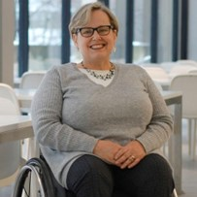 | Heather Willis  Accessibility Coordinator, Toronto Metropolitan University  Born in Toronto, Heather has been an accessibility advocate since she was a teenager growing up in an institution for disabled children. She is a graduate of Toronto Metropolitan’s School of Disability Studies, and has a post-graduate diploma in Disability Studies from the University of Leeds. In 2010, Heather joined Toronto Metropolitan University as its inaugural Accessibility Coordinator, now in the Office of the Vice President, Equity and Community Inclusion. She leads TMU’s accessibility initiative, "ACCESS TMU" with a goal of identifying, removing and preventing accessibility barriers. Outside of TMU, Heather serves on the Board of Directors of Citizens with Disabilities Ontario and is a member of the Metrolinx Accessibility Advisory Committee. Heather keeps the motto “Nothing About Us Without Us” centred in her work, making sure that all TMU initiatives take into account the perspectives of those who have lived experience of disability.
 | HON. Kamal Khera  Minister of Diversity, Inclusion and Persons with Disabilities of Canada, Government of Canada  The Honourable Kamal Khera was first elected as the Member of Parliament for Brampton West in 2015. She has previously served as Minister of Seniors, as Parliamentary Secretary to the Minister of International Development, as Parliamentary Secretary to the Minister of National Revenue, and as Parliamentary Secretary to the Minister of Health.  Minister Khera is one of the youngest women ever elected to Parliament. A registered nurse, community volunteer, and political activist, she is passionate about improving the lives of those around her. Prior to entering politics, she worked as a registered nurse in the oncology unit at St. Joseph’s Health Centre in Toronto, where she gained a deeper understanding of the issues that impact people’s health and well-being every day.  During the first wave of the COVID-19 pandemic, she went back to her roots as a registered nurse to volunteer at a hard-hit long-term care facility in her hometown of Brampton. Minister Khera continued to help on the front lines throughout the pandemic, including by administering vaccines in her community. Truly believing that diversity is our strength, Minister Khera is motivated to create a better present and future for all Canadians.
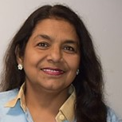 | Husna Sweet  Project Support Worker, South Asian Women’s Rights Organization (SAWRO)  Husna Sweet holds a double master’s in management and human resources from Bangladesh and has over ten years of experience in HR management within a multinational pharmaceutical company. Since immigrating to Canada, she has been an integral part of the South Asian Women’s Rights Organization (SAWRO), initially as a peer worker and now as a Project Support worker. For the past five years, she has focused on the New Comer Settlement Project, funded by the Ontario Ministry of Labour, helping racialized immigrant women integrate into the workforce and navigate settlement challenges. Husna also conducts computer literacy training at SAWRO, equipping women with essential skills like tax filing, budgeting, and online banking. Her extensive knowledge in financial management and literacy positions her well to contribute to the Financial Empowerment for Low-Income Newcomer Immigrant Women Project, aimed at enhancing the economic independence of women in her community. Through her dedication and experience, Husna is committed to fostering financial empowerment among immigrant women, ensuring they gain the tools needed for successful integration into Canadian society.
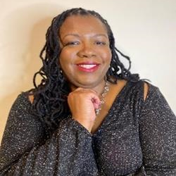 | Ingrid Palmer  Principal IDEAL Advocate (Inclusion, Diversity, Equity, Accessibility, Leading to belonging), Realize  Ingrid Palmer, (she, her), is an award-winning speaker, bestselling author, and holds the position of IDEAL (Inclusion, Diversity, Equity, Accessibility, Leading to belonging) Chief Officer at Realize. As a visually impaired former foster kid, Ingrid is committed to combating discrimination in all its forms, as well as to drive systemic change and debunking myths and stereotypes of stigmatized identities. Ingrid’s dedication is deeply rooted in her living experiences of early childhood trauma, foster care, disability, and gender-based violence. Ingrid’s community service includes the Child Welfare PAC, the Council of Canadians with Disabilities, and the Confronting Anti-Black racism unit.
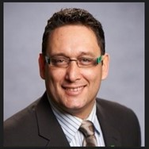 | James MacKay  Indigenous Human Resources Lead, Toronto Metropolitan University  James is from Sault Ste. Marie, Ontario and is a proud Ojibwe member of the Indigenous community of Batchewana First Nation. James began his education and work life in the Environmental Water Resources / Engineering Technology field working in chemistry labs and in the bush doing bio essays for Provincially and Federally funded Environment Research Projects.  Following struggles to find permanent full-time employment in a small blue collar hockey town, James moved to southern Ontario to explore more stable work opportunities. Over the next 20 years he gained experience in Equity Community and Inclusion work volunteering with IBM Canada and in the banking Industry crafting and executing Diversity Talent Acquisition strategies. In 2021 James began the next phase of his career at Toronto Metropolitan University initially as a Talent Acquisition Manager and now as TMU’s Indigenous Human Resources lead. James continues to volunteer his time working in Diversity and Inclusion.
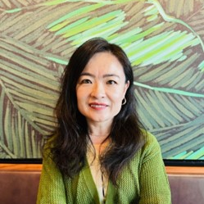 | Jasmine Qi  Director, Workforce Inclusion, Tourism HR Canada  Jiaxuan (Jasmine) Qi is the Director of Workforce Inclusion at Tourism HR Canada, where she leads transformative initiatives to integrate equity-deserving groups into the tourism workforce and promote Diversity, Equity, Inclusion and Accessibility (DEIA) within workplaces. With a strategic approach, Jasmine designs and manages high-impact projects, develops compelling proposals, and conducts thorough policy research and analysis. Her passion for fostering inclusivity drives her mission to create a community where everyone feels they belong. Jasmine brings a wealth of expertise in diversity, equity, and inclusion, human resource management, stakeholder engagement, immigrant settlement and integration, career development, employment counseling, mentorship, and program and proposal development. Her vast experience ensures that she not only leads with purpose but also advocates effectively for inclusive workplaces across the tourism sector. As a visible minority immigrant woman, Jasmine is deeply committed to championing DEIA within both workplaces and the wider community. She believes in creating equitable opportunities for all and is dedicated to empowering individuals to realize their full potential. Jasmine's work reflects her unwavering belief in the power of inclusion to transform lives and strengthen communities.
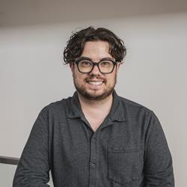 | Jeffrey Normore  Manager of Digital Operations, CCRW  Jeffrey is the Manager of Digital Operations at CCRW, overseeing the organization's eLearning, VR, IT, cyber security, CRM, and digital products. Jeffrey is passionate about how technology can be used for social good across Canada. Jeffrey is located in St. John's, Newfoundland and Labrador and serves on the Government of Newfoundland and Labrador's Accessibility Standards Advisory Board.
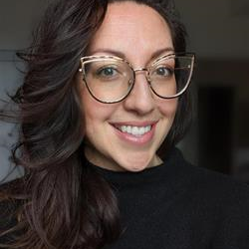 | Jennier Broad  Employment Inclusion Specialist, LiveWorkPlay  Jen joined LiveWorkPlay as an Employment Inclusion Specialist in 2022. Previously, Jen was a manager of a coffeeshop and has worked in the Private Sector for over 20 years where she got to lean into her love of customer service and relationship building. She has always been amazed at the relationships formed over a cup of coffee. She is passionate that every individual deserves the right to a rich and fulfilled life. She aspires to educate and create awareness in employers on the overwhelming benefits of cultivating truly diverse teams. Outside of work Jen loves early mornings, a good cup of coffee, spending time with her partner and two dogs and getting out on the golf course as much as possible!
 | Joanna Patsakos  Accessibility Specialist, LCBO  Joanna Patsakos is a passionate accessibility and diversity inclusion specialist with over a decade of experience in community development and policy creation. At the LCBO, she leads the “We Belong Here” pilot program, an inclusive hiring initiative that has significantly enriched the organization’s talent pipeline by engaging the disability labor pool. Previously, Joanna served as a Senior Policy Advisor for the Ministry for Seniors and Accessibility, where she advocated for and advanced policies to support people with disabilities. She holds a Master of Public Policy from the University of Toronto’s Munk School of Global Affairs and Public Policy, specializing in accessibility and inclusion.
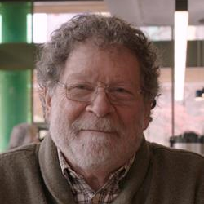 | Jonathon Breen  Research Associate, University of British Columbia  Dr. Breen is a Research Associate in the Faculty of Medicine at the University of British Columbia. His work is focused on the relationships and challenges associated with people with disabilities and employment. His research program has included the development and testing of a self-report questionnaire that measures workplace attitudes toward disabled employees. In addition, Dr. Breen has created and delivered a series of interactive digital training sessions that address attitudes toward people with disabilities in the workplace. He has also developed the Difference Model of disability - designed to support organizations in their efforts to improve the representation rates of people with disabilities within the Canadian and international workforce.
 | Judy Sillito  Program Manager, Multicultural Health Brokers Cooperative  Judy Sillito works in Adult Education and Community Development, primarily in the immigrant-serving sector, where she has worked in English as a Second Language, settlement, narrative approaches, hope studies, digital storytelling, EDI coaching, and the promotion of intercultural perspectives. Currently, she works at Multicultural Health Brokers in Edmonton, supporting newcomers facing multiple barriers to employment. Recently, she partnered with Gateway Association supporting employment for newcomers with complex barriers to employment, including disability. Following this passion for over 40 years, she thrives on deeply relational work with refugees and immigrants, where she finds the inspiration reciprocal.
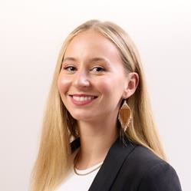 | Julia McEathron  National Coordinator, Indigenous Disability Canada (IDC)  Julia McEathron is the National Coordinator at Indigenous Disability Canada/B.C Aboriginal Network on Disability Society. As National Coordinator for IDC/BCANDS, Julia oversees various organizational capacity, awareness, and engagement initiatives related to Indigenous disability. As a proud Algonquin-Anishinaabe and mixed-settler woman with a strong professional and academic background, Julia is committed to truth and reconciliation and honouring her ancestors by advancing the priority of Indigenous disability within Canada. Julia is grateful to reside on the unceded, unsurrendered, traditional territory of the Algonquin-Anishinaabe Peoples in Ottawa, Ontario. In her free time, you can find her running or biking alongside the Kitchissippi (the Ottawa River)
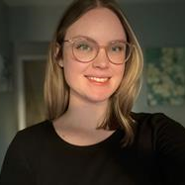 | Julianna Cougle  eLearning Developer, CCRW  Julianna Cougle is a eLearning and Curriculum Developer at the Canadian Council on Rehabilitation and Work (CCRW). With a strong educational background, Julianna holds a degree in Criminology and Justice, an eLearning Developer Certificate from Seneca College, and a Graduate Diploma in Education and Digital Technologies from Ontario Tech University. Since joining CCRW in 2020 as an Employment Facilitator, Julianna has been dedicated to creating inclusive and accessible learning environments that empower individuals with disabilities and inform employers and community partners about accessible employment practices. Julianna is a continuous learner and educator of Equity, Diversity, and Inclusion (EDI), accessibility, accommodations, and social justice. She is committed to educating staff and stakeholders on inclusive employment practices and is always seeking to expand her knowledge in these areas. Her work is driven by a passion for social justice and a commitment to fostering equitable opportunities for everyone.
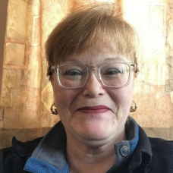 | Kathy Hawkins  Executive Director, Empower, The Disability Resource Centre  Kathy Hawkins (She/Her) serves as the Executive Director of Empower, The Disability Resource Centre, which includes their Corporate Services – InclusionNL. Kathy has extensive knowledge and expertise in the services available for people with disabilities. She supports employers in creating inclusive workplace environments for current and new employees with various types of disabilities. In  her role, she advises businesses on all aspects of creating barrier-free work environments, including recruitment and hiring, accessibility reviews of physical locations, reasonable workplace adjustments and employee accommodations, staff training, and professional development. Kathy also holds professional certification in website accessibility from the University of South Australia and provides expertise to businesses interested in creating accessible websites, mobile apps, technical applications, and online platforms. Currently, Kathy is the President of the DisAbled Women's Network of Canada, sits on the IL Canada Accreditation Committee, is a new Board Member of Persistence Theatre Company, and an active member of the International Association of Accessibility Professionals.
 | Keenan Wellar  Co-Leader and Director of Communications, LiveWorkPlay  Keenan Wellar is Co-Leader and Director of Communications at LiveWorkPlay, serving as the public face of the organization, championing inclusion for people with intellectual disabilities and autistic persons in the Ottawa area community, as well as provincially as a founding member of From Presence To Citizenship, and internationally via Inclusion International.
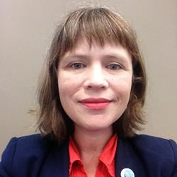 | Kelci Archibald  Lead Coordinator, Career Education  Kelci Archibald (she/her) – Kelci is the Lead Coordinator, Career Education at Career Exploration and Education, University of Toronto. She brings a creative and collaborative approach to her work and is deeply committed to social justice career education. Prior to this, Kelci spent 8 years as a Career Educator supporting students, individually and in groups, in building their future career stories. Kelci has an Honours B.A. in Theatre from Dalhousie University, a B.Ed. from OISE and a M.Ed. in Adult Education from OISE.
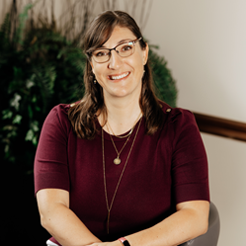 | Kelly Stewart  Occupational Therapist/ Training Manager, Gowan Consulting  Kelly Stewart, Occupational Therapist and Training Manager with Gowan Consulting brings nearly two decades of diverse experience in occupational therapy to her role. A graduate of the University of Western Ontario's Master’s in Occupational Therapy Program, Kelly's career spans a wide range of settings, including acute care hospitals, rehabilitation centers, outpatient programs, community care, and private clinics. In her current role at Gowan Consulting, Kelly specializes in assessing and implementing work accommodations and return-to-work strategies for clients across various industries. Her extensive experience includes addressing the challenges faced by workers dealing with mental health and cognitive issues, with a notable focus and specialization on working with neurodivergent employees. Kelly is a strong advocate for disability inclusion in the workplace. She has provided valuable insights through presentations at various organizations and conferences on subjects including neurodiversity, effective support strategies for neurodivergent employees, inclusive work practices, and fostering psychological safety at work. Her expertise in this field is further demonstrated by her recent engagements at the Ontario Occupational Health Nurses Association’s annual conference and the Schedule 2 Employers Conference.
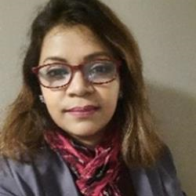 | Kishower Laila  Project Support Coordinator, South Asian Women’s Rights Organization (SAWRO)  Kishower Laila is a committed member of the South Asian Women’s Rights Organization (SAWRO) in Canada, where she has worked since her migration. She began her journey as a Peer Outreach worker and has advanced to a community leader role. Currently, she is a Research Assistant on a project titled “Working and Hurting in Little Bangladesh,” in collaboration with McMaster University, focusing on the experiences of racialized immigrant workers in precarious jobs. With 12 years of prior experience as a television journalist in Bangladesh, Kishower holds both Bachelor’s and master’s degrees in mass communication and journalism.  She has also earned a diploma in Child and Community Development in Canada, linking her academic background to her community work. Passionate about intersectional gender equity, she advocates for the rights of marginalized and racialized newcomer women, aiming to ensure their full participation in Canada’s economic and social life. Kishower’s work exemplifies her commitment to supporting and empowering her community, fostering a more equitable society.
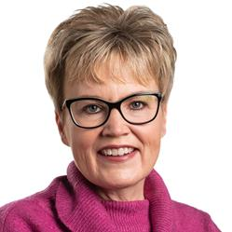 | Krista Carr  Executive Vice-President, Inclusion Canada  Krista Carr is a long-time advocate in the inclusion movement. She is the Executive Vice President (CEO) of Inclusion Canada, one of Canada’s 10 largest charitable organizations. Inclusion Canada is a national federation of 300 local and 13 Provincial/Territorial Associations working on behalf of approximately 1 million Canadians with a developmental disability and their families. Krista has over 25 years of experience in the non-profit sector as a champion of inclusion. Before joining Inclusion Canada, she was the Executive Director of the New Brunswick Association for Community Living (NBACL), a leading provincial non-profit organization that works with people with an intellectual disability and their families to accomplish the mission of full inclusion across the lifespan. In her current role, Krista is responsible for leading the Inclusion Canada National organization, the Inclusion Canada Foundation, Inclusive Education Canada (IEC). In addition to her extensive work portfolio, Krista sits on a number of provincial and national disability-related boards and committees. This includes the COVID Disability Advisory Group (CDAG), chaired by the honourable Carla Qualtrough, Minister of Employment and Disability Inclusion. Krista offers a unique perspective on disability-related supports and services, both nationally and internationally. Krista is a graduate of the University of New Brunswick (UNB) where she earned a Bachelor’s in Business Administration (BBA) and several diplomas in Human Resources and Management from UNB’s College of Extended Learning. She is fluently bilingual and works on behalf of CACL’s federation in both French and English. She currently resides in New Brunswick with her husband and two daughters.
 | Lauren Reynolds  Ph.D. Clinical Psychology Student, Lakehead University  Lauren Reynolds is a student currently enrolled in the Ph.D. Clinical Psychology program at Lakehead University in Thunder Bay, Ontario. Her research interests include mental health stigma and stigma associated with workplace injuries. Lauren’s master’s thesis examined the lived experiences and perspectives of stigma experienced by injured workers in Ontario.
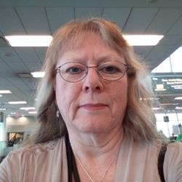 | Laurie Whyte  Library Assistant - CUPE 951 Return to Work & Accommodation Steward, Canadian Union of Public Employees  Laurie is a volunteer Return to Work & Accommodation Steward for Canadian Union of Public Employees (CUPE) Local 951 at the University of Victoria. In this role, Laurie helps 951 members stay at work (with a suitable accommodation), return to work after a sick leave (with or without the need for a suitable accommodation), and help members achieve the best possible medical or equity accommodation to meet their needs. Laurie works collaboratively with her counterparts in Human Resources, the Work Life Consultants, to help guide 951 members through the Return to Work and Accommodation process for a successful outcome.  Laurie also sits on the CUPE 951 Negotiating Committee and has done so since the early nineties. She helped negotiate Duty to Accommodate language when the Human Rights Code of BC first introduced it. That language has stood the test of time, with just minor tweaks necessary over the years.  Laurie is the Diversity Vice-President Persons With Disabilities for CUPE BC, chairs the CUPE BC Persons With Disabilities Committee, and sits on the CUPE National Persons With Disabilities Committee.  Laurie is passionate about disability rights, and self-identifies as a person with multiple, she hopes mostly, invisible disabilities. She is constantly fighting to raise awareness of the fact that not all disabilities are visible, and that you can’t have real inclusion without accessibility – She’s often been heard to exclaim: you can be inclusive and invite me to the table, but if I can’t get to the table, then it isn’t really inclusive.
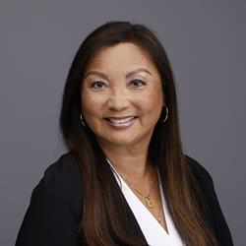 | Lily Chang  Secretary-Treasurer, Canadian Labour Congress  Lily Chang was re-elected Secretary-Treasurer of the Canadian Labour Congress (CLC) at the 30th Constitutional Convention in May 2023. She is the first worker of East Asian descent elected to office at the CLC. As the CLC’s Secretary-Treasurer, Lily oversees the organization’s finances. She has also been tasked with guiding the work of the Human Rights Department (including Indigenous and Disability Rights working groups). Apart from her role at the CLC, Lily proudly serves on the International Labor Organization Governing Body as well as the Global Coalition for Social Justice Coordinating Group. At the 2023 International Labor Conference, she was honoured to be the Workers’ Vice-Chair, leading the general discussion on Decent Work and the Care Economy. Lily also serves on the Boards of the United Way Centraide Canada and the Council of Canadians. After obtaining a Psychology degree from the University of Toronto, Lily started her career as a social services caseworker. She saw first-hand how inequality and racism were linked to poverty. The disparities she saw and the cuts to education affecting her children fueled her interest in labour work. Lily spent over three decades advocating for members at CUPE Local 79 and thirteen years as the local’s Treasurer. A strong defender of public services, she fought against efforts to contract out and privatize city services. As Chair of the Toronto and York Region Labour Council Municipal Committee, Lily worked with affiliates and community allies to elect progressive candidates to City Hall. She also served on the Board of Trustees of United Way Greater Toronto, representing labour. Lily is the proud mother of a daughter, also active in the labour movement as a researcher, and a son, who works designing clean energy solutions.
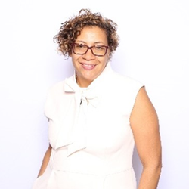 | Liza Arnason  Founder and Chair, Ase Community Foundation for Black Canadians with Disabilities  Liza Arnason BA, MA in Sociology and Equity Studies in Education at UofT's Ontario Institute for Studies in Education, is the Owner of Arnason Consulting, Chair of the UCalgary Black Alumni Network, founder and Chair of the Ase Community Foundation for Black Canadians with Disabilities, and above all a mom, grandma, and mentor.  Liza's commitment to the principles of "nothing without us" and "for us, by us”, has always been the cornerstone of her work as an educator, administrator, and community advocate. Her depth of knowledge and expertise is informed by her lived experiences, research and policy initiatives, and work experience over 30 years. Liza draws on critical pedagogy including Black Feminism, disability justice, and critical race theories to inform community-based research and policy change initiatives. She unapologetically brings the lived experiences of those intersectional experiences of race, gender, and disability to the “table”, identifying nuances, gaps, and disparities within systems, structures, and research. Through collective leadership across Canada, Liz continues to design and advocate for new models and systems that will affect real change.
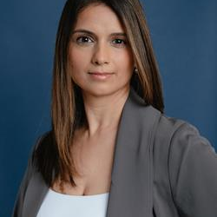 | Lizna Husnani-Puchta  Senior Manager, EDI & Accessibility Lead, Coast Capital Savings  Lizna Husnani-Puchta (She/Her/Hers) is the Senior Manager of Equity, Diversity, and Inclusion, and Accessibility Lead at Coast Capital. With a strong background as an occupational therapist specializing in disability management, accommodations, and accessibility, Lizna’s leadership is influenced by her professional experience and personal advocacy. As a mother to a child with a disability and a South Asian woman living with a hidden disability, she brings a uniquely empathetic and intersectional perspective to her work. Lizna also serves as a Board member for BALANCE for Blind Adults and as a Co-Chair for the Canadian Credit Union Association (CCUA) DEI Working Group. These positions allow her to apply her extensive knowledge and passion for EDI on a broader scale, impacting policies and practices across different organizations and communities.
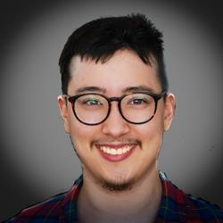 | Logan Wong  Research Assistant, McMaster University  Logan identifies as a trans, bi-racial, Autistic wheelchair user and is a social worker & equity, anti-racism, anti-oppression, & accessibility professional. He currently works at McMaster University as a research assistant within the School of Rehabilitation Sciences and is an entrepreneur and the owner of IDEAA Perspectives Training & Consulting, a consulting firm specializing in Inclusion, Diversity, Equity, Accessibility and Anti-Racism (IDEAA).
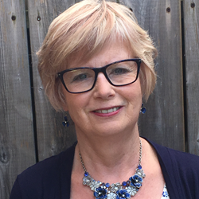 | Lynn Cooper  Director Research and Education, Canadian Injured Workers Alliance  Lynn Cooper is the Director of Research and Education of the Canadian Injured Workers Alliance. She is a person with more than 30 years lived experience with work injury and subsequent chronic pain and disability. Lynn manages the CIWA/Lakehead University injured worker stigma research project.
 | Lys LeClair  Neurodivergent Interdisciplinary Artist and Advocate for Disability Rights, Realize  Lys LeClair (they/them) is a neurodivergent interdisciplinary artist and advocate for disability rights. Through their work in the arts, writing, and performance, they hope to raise awareness about disability & accessibility rights, queer politics, and destigmatizing mental health. With a deeply community-focused approach driven by a commitment to mutual aid and community care, Lys draws inspiration from their own lived experiences as well as the stories and experiences of their communities. Their aim is to create works and environments that encourage viewers to witness, learn, and understand the realities faced by marginalized groups and individuals.
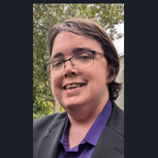 | Maggie Lyons-MacFarlane  Human Rights Officer, DAWN Canada  An activist in the cross-disability communities for years, ranging from local and regional to national. Maggie identifies as having invisible disabilities along with being queer and non-binary. They have volunteered, worked and served as a community navigator and educator within the cross-disability community for 2 decades. Maggie holds a Master of Arts in Education with a focus in critical disability studies.
 | Mahadeo Sukhai  Steering Committee, Founder and Co-Principal, IDEA-STEM Consulting  Dr. Mahadeo Sukhai is the world’s first congenitally blind geneticist. Mahadeo has more than 20 years’ experience as an accessibility and inclusion professional, and as a researcher within this space, as well as more than 25 years’ experience as a scientist, researcher and educator in the medical sciences and healthcare related disciplines. Dr. Sukhai is a leading expert on accessibility of postsecondary education and employment for persons with disabilities. Dr. Sukhai is one of the originators of the discipline of and discourse on accessibility and inclusion in the sciences and in healthcare. He is the Chair of the Employment Technical Committee for Accessibility Standards Canada, tasked with developing accessible employment standards; as well as, the External Co-Chair of the Canadian Institutes of Health Research Expert Advisory Committee on Accessibility and Systemic Ableism. Mahadeo also serves on the Boards for Health Data Research Network Canada and the Institute of Neurodiversity Canada, and is a member of the steering committee for Disability and Work in Canada.
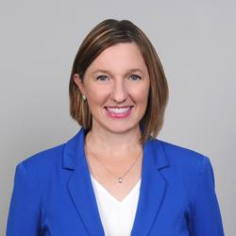 | Mandi Crespo  Manager - Accessibility Consulting, BDO Canada  Mandi is a Manager of Accessibility Consulting Services at BDO Canada. She is a passionate accessibility advocate, leveraging her lived experience of disability and her expertise in inclusion to drive meaningful change across Canada. With a keen focus on advancing accessibility, she has spearheaded numerous initiatives aimed at fostering inclusivity and breaking down barriers. At BDO Canada, Mandi has been the Project Lead on over 25 accessibility projects for organizations such as Accessibility Standards Canada, Coast Capital Credit Union, Canadian Tire Financial, Capital One Canada, Employment and Social Development of Canada, TELUS, the Trans Mountain Pipeline. She has also been a key contributor in driving accessibility and inclusion forward within BDO through drafting the firm’s inaugural accessibility plan and supporting internal systematic and cultural change. Mandi was previously the Program Manager of the Canadian Accessibility Network (CAN) where she led initiatives to increase collaboration across Canada’s accessibility assets. Before joining CAN, Mandi served as an internal consultant at Carleton University where she spearheaded accessibility, benchmarking, strategy, planning and change management efforts. She managed large-scale projects related to accessibility, digital transformation and university restructuring. She also facilitated faculty and departmental change and continuous improvement initiatives. As a certified trainer, Mandi was a lead content developer and facilitator for university-wide learning and professional development programs and workshops.
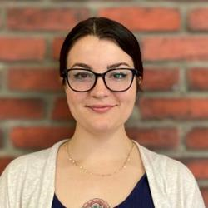 | Mara Wheelehan  HR Generalist, Ottawa Mission  Mara Wheelehan joined The Ottawa Mission June of 2023 as an HR Generalist. She plays a key role in recruitment and onboarding, ensuring an accessible, non-judgmental, and accommodating process for all. Mara is committed to fostering open conversations and supporting employees in improving their workplace experience, particularly as Chair of the Wellness Committee. Her work includes arranging accessible interviews, organization wide policy conversations, and ensuring appropriate disability training for all employees. With a background in street-based outreach during the COVID-19 pandemic and an honors degree in Political Science and Indigenous Studies, she brings a deep understanding of inclusivity to her HR practice, particularly in creating supportive environments where all can thrive.
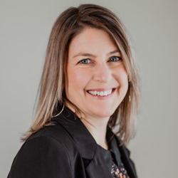 | Marie Laberge  Professeure titulaire, Université de Montréal  Dre Laberge a une formation initiale en ergothérapie, puis s’est ensuite spécialisée en ergonomie (PhD UQAM, 2011). Sa programmation de recherche porte sur la prévention de l'incapacité au travail et l’intégration professionnelle des adolescents pour qui l’accès à la vie active représente un défi. Par ailleurs, elle étudie les différences dans l’exposition à certains facteurs de risque selon les sous-populations et leurs effets sur la santé au travail : différences hommes-femmes, différences liées à l’âge, au statut socio-économique, à l’origine culturelle, aux situations de handicap, etc.
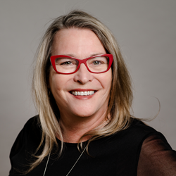 | Maureen Haan  President & CEO, Canadian Council on Rehabilitation and Work (CCRW)  Maureen Haan has been the President & CEO of CCRW since 2012. CCRW is the only national organization with the sole vision of equitable and meaningful employment for people with disabilities, in operation for over 40 years. CCRW provides direct services focusing on employment engagement through CCRW best practices and proven results. Maureen has been very active in the cross-disability sector, currently focusing on employment issues. She has been involved with numerous committees and groups that increase awareness of and access for the disability sector and the Deaf community, including involvement with Civil Society on the UN Convention of Rights for Persons with Disabilities (CRPD), and as a Board member on the Accessibility Standards Canada. Maureen was appointed to the COVID-19 Disability Advisory Group (CDAG) during the COVID-19 pandemic and continues to serve in the Minister Disability Advisory Group (MDAG).
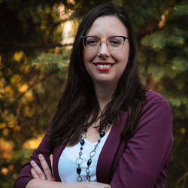 | Megan Pilatzke  Inclusion Specialist, Specialisterne Canada  Megan is a proud autistic woman and member of the 2SLGBTQIA+ community. She works as an Inclusion Specialist with Specialisterne Canada, a not-for-profit dedicated to enabling meaningful jobs for neurodivergent Canadians. She works with employers to facilitate neuro-inclusion in workplaces across Canada and the United States. Megan is a thought leader and public speaker who is dedicated to promoting acceptance, inclusion, and accessibility for autistic and neurodivergent individuals, particularly in employment and in healthcare. She does this through openly sharing her lived experience and professional insights. Some of her previous public speaking collaborations include Autism Canada, CAMH, Flourish Health Services, CBC, Globe and Mail, and The Senate of Canada. Megan is an academic researcher and author, having recently published her first peer-reviewed article on the employment experiences of autistic employees.
 | Meghan Kelly  Vice President, INNoVA  Working out of St. John’s, Newfoundland Meghan has been leading change in the space of Disability and Employment since 2013. With a background in Psychology and Education, Meghan started her career in this space at CCRW, and has transitioned into her current role as Vice President at INNoVA -an innovative employment strategies firm with evidence informed solutions focused on creating dynamic inclusion for Canadian workforces. Meghan has been involved on varying levels of project, solution, and service design and delivery and she leads INNoVA in the work they design for Business. Meghan’s most recent area of focus, outside of being a mom of a 2-year-old and an 9-year-old, has been concentrated in showcasing INNoVA’s expertise, working directly with business and ensuring best in class delivery of customized accessibility consulting services.
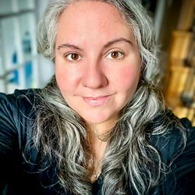 | Melanie Green  HR Consultant, Equal Employment Opportunities Program, Government of New Brunswick  I’m an HR Consultant with the Government of New Brunswick’s Equal Employment Opportunity Program. As an autistic woman with ADHD, I bring my lived experience, a background in psychology, and research on autistic employment to the work I do. I’m passionate about creating initiatives that foster inclusive and equitable work environments. Currently, I’m leading the development of 360° interactive maps of GNB buildings, designed to improve navigation for all employees by incorporating customizable routes, sensory details, and process guidance. I’ve also designed and facilitated training to build disability confidence in workplaces, advancing accessibility and inclusion. Beyond that, I’m exploring mentorship and sponsorship programs to support career growth for individuals from equity-deserving groups. My work is grounded in the belief that lived experience, paired with research and intentional action, has the power to create meaningful change and make workplaces more equitable for everyone.
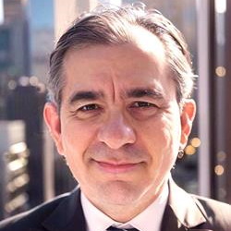 | Michael Aguayo  Consultant, Disabled Activist Services  Miguel Aguayo, M.S.W. has recently founded Disabled Activist Services and has more than 30 years of work experience in promoted diversity and programs that address gaps in workforce representation for women, visible minorities, Indigenous people, and particularly disabled people.  Miguel has led and/or supported programs with federally and provincially regulated employers intended to enhance diversity, accessibility, and conducted employment systems reviews, as well as research on employment strategies that expand employment opportunities for disabled people.  A list of organizations that he as worked with includes, but not limited to, the Ontario Public Service, Canadian Border Services, Canadian Imperial Bank for Commerce, Canada Life Assurance, Royal Bank of Canada, Compass Group, the Canadian Manufacturers and Exporters, Bank of Montreal, the United States Postal Service, and more.  Miguel became deafened at the age of 14 years and has earned a Master of Social Work degree from Wilfred Laurier University, a Masters Certificate in Public Management from York University, and certificates in Human Resources Management and Nonprofit and Voluntary Sector Management from the Toronto Metropolitan University.
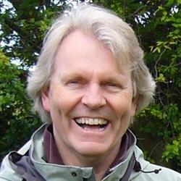 | Michael Prince  Landsdowne Professor of Social Policy, University of Victoria  Michael J. Prince is the Lansdowne Professor of Social Policy at the University of Victoria. A long time community activist and volunteer, Prince is currently a member of the Canadian Disability Advisory Group to the federal Minister of Disability and Inclusion.
 | Mike Perry  Acting Director, Employment and Social Development Canada’s Skills for Success Program  Mike Perry is the acting Director of Employment and Social Development Canada’s Skills for Success Program. Mike began his full-time career as a public servant in 2000 and progressed through increasingly senior positions. He has spent his career at the forefront of program policy design to support Canadians; including, persons with disabilities, youth, Indigenous Peoples, newcomers, as well apprentices and skilled tradespersons improve their skills and find employment.  In his current role as the acting Director of the Skills for Success Program, Mike is leveraging his 20+ years of experience to help adult learners across Canada improve their foundational and transferrable skills such as literacy, digital, and social-emotional skills to assist them be more resilient and successful to get and keep good jobs in today’s economy. Mike is also supporting the Disability Inclusion Business Council, which is a Ministerial Advisory body comprised of 10 business leaders that are championing and advancing disability inclusion in workplaces.
 | Mitch Lawson  Manager - Employment Services, CATALYST  Mitch Lawson has been working in the disability sector for over 11 years, but also has years of experience in Business-To-Business relations through years of work in the private sector. Since 2018, he has been running CATALYST – an employment program based in Lethbridge, Alberta that supports job seekers with disabilities. CATALYST employs an approach to job development that focuses heavily on relationships and business engagement. CATALYST also provides training, guidance and capacity-building support to employers, which has helped to generate highly successful employment connections for the people they support. Mitch has brought in strategies and tools from his time in the business community, and has developed a strategy for engagement that is employer-focused – while still aiming to drive meaningful results for those that CATALYST supports.
 | Mitchell Daniels  Ability Acceptance Presenter and Archivist, Grandview Kids  Mitchell Daniels is the Grandview Kids Ability Acceptance Presenter and Archivist. Born with Hydrocephalus, Strabismus, and later diagnosed on the Autism Spectrum. Mitchell provides disability awareness presentations speaking about his lived experience while providing advice for working with individuals with disabilities. Mitchell also works as a vocalist, specializing in Jazz, Broadway and Opera, and has performed at various events in and around the Greater Toronto Area (GTA), including conferences, galas, sporting events, and government events. For his work, Mitchell received the Accessibility Community Volunteer Award from the Town Ajax, the Lieutenant Governor’s Volunteer Award, Peter Dickinson Award, and was also named a recipient of her Majesty Queen Elizabeth the Second Diamond Jubilee Medal. Mitchell has appeared on countless documentaries, radio and TV shows including TVO and AMI (Accessible Media Inc), Employable Me television series, a 2016 documentary titled “Hold Me Steady: A Story of Autism Service Dogs”, CBC’s Our Toronto television series, and an independent documentary about Autism Awareness Day called “FridAy!” Outside of his work, in disability awareness, Mitchell also works as an Educational Interpreter at Black Creek Pioneer Village (rebranding to The Village at Black Creek in October 2024) in Toronto, Tour Guide with Heritage Toronto and the Canadian National Exhibition; in addition, Mitchell also serves as a Board Member for the Whitby Historical Society, Program Advisory Committee Member for Centennial Colleges, Museum and Cultural Management program and was recently appointed to the Town of Ajax’s Heritage Advisory Committee. It is through this work that Mitchell hopes to inspire those of all abilities to strive to be the best possible version of themselves and for workplaces to include people of all abilities.  During this conference, Mitchell will discuss the importance of ability acceptance and strategies for employers, individuals with disabilities looking for work or both that can be implemented in the workplace to make them more accessible, drawing both from his professional and lived experiences discussing themes of ableism, allyship, and workplace accessibility modifications.
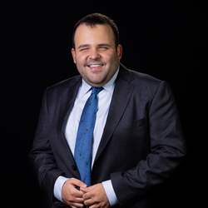 | Mohammed Elshafie  Associate, Conway Baxter Wilson  Mohammed is a blind lawyer who is developing a broad, multilingual litigation and advisory practice, with equal emphasis on commercial, administrative and constitutional law. Mohammed received his JD from Harvard Law School, and, before joining Conway Baxter Wilson as an associate, completed his articles at the Firm as a candidate in the Programme de pratique du droit. A proud Egyptian revolutionary, Mohammed’s experience of the thrilling triumphs and bitter disappointments of the Arab Spring gave him direct insight into the delicate interplay of law and politics, and taught him invaluable lessons in the arts of negotiation and extempore eloquence. Having had a glimpse of the majesty and power of the Law, Mohammed conceived the ambition of mastering its every aspect: he divided his law school summers between researching the intricacies of the Rome Statute in The Hague and lobbying for more merciful landlord and tenant laws in Mississippi, was a research and teaching assistant in constitutional law and civil procedure, and felt equally at ease discussing Thomas of Canterbury’s interpretation of Canon Law and co-authoring a report on the Black November Massacres in Bolivia for the Harvard International Human Rights Clinic. An avid learner and teacher of languages, Mohammed has served clients in English, French, Arabic and Spanish, and prays for the day when he may add Latin to the list.
 | Nadine Charron  Executive Director of the Accessibility, Accommodation, and Adaptive Computer Technology (AAACT) Program, Shared Services Canada  Nadine Charron is the Executive Director of the Accessibility, Accommodation, and Adaptive Computer Technology (AAACT) Program at Shared Services. With a wealth of experience in the field, Nadine has dedicated her career to advancing accessibility and inclusion in various environments. She holds a Master’s Degree in Leadership and Adult Education, equipping her with the skills to drive meaningful change and empower individuals.  Throughout her career, Nadine has been a passionate advocate for the rights of individuals with disabilities, championing innovative solutions that enhance their access to technology and services. Her leadership has not only transformed organizational practices but has also inspired countless professionals to prioritize accessibility in their work. Nadine’s commitment to fostering inclusive communities and her expertise in adaptive technology make her a sought-after speaker. She brings valuable insights and practical strategies for creating environments where everyone can thrive. Her work continues to make a significant impact, paving the way for a more equitable future.
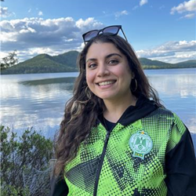 | Nashwa Lina Khan  Senior Research Associate, DAWN Canada  Nashwa Lina Khan (she/her) is a community educator, facilitator, and researcher. She is also a writer and poet and occasionally dabbles in installation and archive that uses narrative methodologies. She holds a Masters of Environmental Studies from York University with areas of concentration focused on narrative methodologies, community and public health, refugee, and forced migration studies. She is currently a PhD student in the faculty of Environment and Urban Change and curated/supported the On Display/For Review artist residency at Whippersnapper. nashwa is currently working on a chapbook project, she is currently at DAWN Canada and Rainbow Faith and Freedom working on research and knowledge mobilization. She is a multi-modal artist and uses art-activism through methods such as wheatpasting, projection, altering public spaces through audio, video, and messaging. She was previously with the BIPOC advisory committee at Telefilm Canada and a researcher with Proclaiming Our Roots, and the University of Alberta faculty of Nursing. You can find her cultural commentary on the podcast Habibti Please.
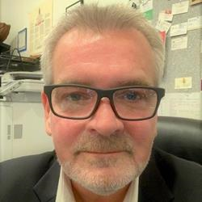 | Neil Belanger  Chief Executive Officer, Indigenous Disability Canada  Neil Belanger has over 30 years of experience working within in Canada’s Indigenous and non-Indigenous disability and health sectors. For the past ten years, Neil has been the Executive Director of the British Columbia Aboriginal Network on Disability Society or BCANDS, an Indigenous disability organization holding Special Consultative Status with the United Nations. BCANDS provides a variety of programs and services relating to Indigenous disability across Canada. BCANDS work has been highlighted through numerous provincial, national and international awards and recognition, the most recent being the Zero Project International Award presented to the Society in Vienna, Austria, in 2019. In addition to his work at BCANDS, Neil serves in a variety of disability related advisory roles,
 | Nicole Flynn  CEO, Nicole Flynn Enterprises  Nicole Flynn lives in rural Centre Hastings, northwest of Kingston. She is a graduate of the General Arts and Science program at Loyalist College. Nicole is a lifelong learner with a strong passion to travel around the world, increasing the awareness of issues that affect people with disability, specifically Down syndrome.  Flynn wrote about the opportunity she has had to live a typical life; one were having Trisomy 21 has not stopped her. Her book, A Life Worth Living, was published in 2023. Nicole encourages people to embrace change by taking one step at a time and enjoying the journey. Nicole’s business, Nicole Flynn Enterprises, highlights her photography, philosophy, and presentation skills. Through the sharing of lived experience, Nicole presents the on-going systemic challenges that affect the inclusion of diverse people in the ideological aspects of  Flynn’s philosophy is to ensure all voices are heard at the table, challenging the status quo, diminishing the hierarchy, and making positive change happen where it matters.
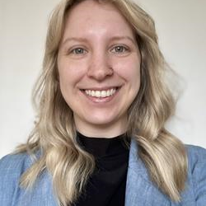 | Nicole Collier  Research Officer, Eviance  Nicole Collier is a Research Officer at Eviance. She holds a Bachelor of Philosophy (BPhil) in Interdisciplinary Leadership from the University of New Brunswick, where she developed an interest in policy, entrepreneurship, and governance. Nicole comes to Eviance with previous project experience in the areas of food security, mental health advocacy, and community development, and is excited to further her knowledge and work in the area of disability justice and intersectionality.
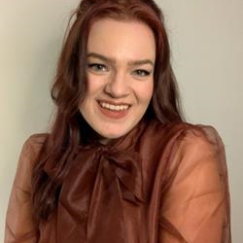 | Olivia Boonstra  Senior Research Officer, Eviance  Olivia Boonstra completed their Masters (MA) in Criminology and Social Justice at Toronto Metropolitan University (TMU) and has worked in community for the past eight years. Olivia has a varied experience having previously worked on projects focused on harm reduction, anti-hate initiatives, prison abolition, and the issue of student debt for students with disabilities. Currently, Eviance is working on a long-term project investigating barriers for students with disabilities accessing post-secondary education and decent work.
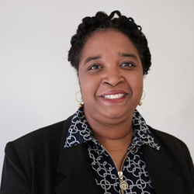 | Pascale Caidor  Assistant professor, Université de Montréal (UQAM)  Je suis professeure en communication au Département de communication de l'Université de Montréal et titulaire d'un doctorat en communication organisationnelle de la même institution. Mes recherches portent principalement sur les questions d'équité, de diversité et d'inclusion (ÉDI) dans une perspective communicationnelle, ainsi que sur la relation entre les relations publiques et les différentes formes d'inégalité, et leur impact sur la justice sociale. Avec plus de 15 ans d'expérience au sein de diverses organisations, j'ai acquis une compréhension approfondie des dynamiques organisationnelles. En reconnaissance de mes contributions, j'ai reçu en 2023 l'Emerging Scholar Award, un prix d'excellence décerné aux États-Unis par le Common Ground Research Network. Ce prix souligne mon travail novateur et perspicace sur la diversité au sein des organisations. J’ai aussi reçu le prix d’excellence en enseignement de l’Université de Montréal en 2017. Les résultats de mes recherches ont été publiés dans plusieurs revues renommées évaluées par les pairs, notamment le Journal of Business Diversity, Communication et Organisations, Environment and Social Psychology, le Canadian Journal of Communication, ainsi que le British Medical Journal. Enfin, j'ai donné de nombreuses conférences au niveau régional et international, mettant particulièrement l'accent sur l'intégration de l'ÉDI dans le contexte de la recherche.
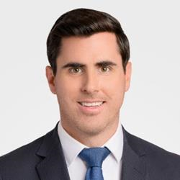 | Paul Leckey  Director of Talent Acquisition, University Pension Plan Ontario  Paul has nearly 15 years of recruitment experience and is currently the Director of Talent Acquisition at University Pension Plan Ontario, leading the TA function with Canada’s youngest joint sponsor pension plan. Prior to joining UPP, Paul was instrumental is building the talent acquisition function at Canada Life, and also worked in England, leading Canada Life UK’s Talent Acquisition team. Paul is really excited and honoured to be here today!
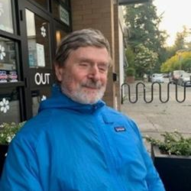 | Peter Field  Diversity and Inclusion Consultant, self-employed  Peter Field is a diversity and inclusion consultant living in Hope British Columbia. For 28 years peter held positions of increasing responsibility with the Government of Canada in areas like employment equity, duty to accommodate, learning, leadership, human resources policy and labour relations. In 2019 Peter retired from his federal government career to pursue consulting and his passion as a marathon runner and podcaster.
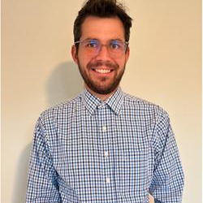 | Philippe Sénécal  Stagiaire de recherche, Université de Montréal  Philippe a complété ses études de premier et deuxième cycle en comptabilité professionnelle à HEC Montréal. Celui-ci a travaillé auprès des PMEs et grandes entreprises et occupait le poste de directeur en transformation financière chez Intact Assurances avant d’entreprendre des études en médecine à l’Université de Montréal. Philippe possède également une maîtrise en administration des affaires (MBA) en gestion stratégique des entreprises de l’Université de Sherbrooke et est actuellement stagiaire de recherche au sein de la chaire ADO-PrevIT.
 | Phoebe Newhook  Human Resources Advisor, Innovation, Science and Economic Development Canada (ISED)  Phoebe is a Human Resources Advisor at Innovation, Science and Economic Development Canada (ISED), where she oversees the LiveWorkPlay partnership and leads initiatives focused on the recruitment and inclusion of persons with disabilities. She believes that diversity without inclusion is incomplete and approaches her work through an intersectional, human-centered lens. Residing in Ottawa, on the traditional unceded territory of the Algonquin Anishinabe Nation, Phoebe enjoys exploring outdoors year-round, playing music, and spending quality time with family and friends.
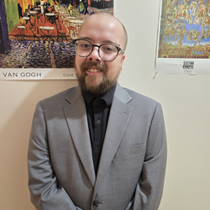 | Quinn Jenkins  Chief Executive Officer, Human Element Education  Quinn J. Jenkins is the CEO and Founder of Human Element Education. In this role, he promotes understanding, empathy, and connection with those who experience mental health concerns and neurodiversity.  With 13 years of experience in the psychiatric system, he is intimately familiar with the lived reality of coping with and managing multiple conditions. Using this experience, he seeks to educate others and uplift the myriad communities to which he belongs.
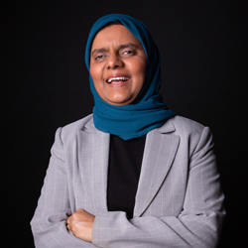 | Rabia Khedr  National Director, Disability Without Poverty  Rabia is dedicated to equity and justice for persons with disabilities, women and diverse communities. She is the National Director of Disability Without Poverty and CEO of DEEN Support Services.  A founder of Race and Disability Canada, she is also a board member of the Muslim Council of Peel and the Federation of Muslim Women. Rabia recently served as a Director on the board of Accessibility Standards Canada, as a member of the Minister’s Disability Advisory Group and previously served as  a Commissioner for the Ontario Human Rights Commission.  A motivational speaker and a documentary commentator, Rabia has campaigned in municipal elections to serve as a city councillor in Mississauga.  Rabia has received numerous awards for her humanitarian services, including a Queen Elizabeth II Diamond Jubilee Metal.  Rabia holds a Bachelor of Arts (University of Toronto) and a Master of Arts (York University). Rabia is a married mother of four young adults, has siblings with disabilities and is blind.
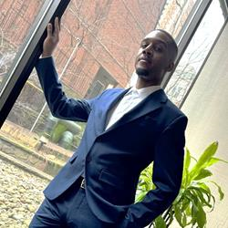 | Raheme Perry  Community Advocate and Website Developer, Realize  As a queer person of color who has been diagnosed with Chronic Schizophrenia and Depression, Raheme (he/him) has experienced many challenges navigating my treatment and care. He is no stranger to stigma; having been bullied and harassed because of a diagnosis that very few people can comprehend. Like many others, he has been misdiagnosed on multiple occasions by different psychiatrists. Raheme hopes that by sharing his lived experience, others who experience similar mental health challenges can see their reflection in his story, find hope and create community. He is passionate about using his voice for those who, just as he thought, don't believe they do. He knows he is not alone. Raheme hopes to challenge the stigma and systems that do not fully understand what it is like to live with chronic schizophrenia. He is both a community advocate and website developer. As an advocate, he facilitated workshops on mental health and documented his story on ‘Living with Schizophrenia’ which was shown at a national conference, hosted by Realize, at its Annual Disability & Work Conference. He has also spoken of his experiences at several of their workshops. As a website developer, he works in the non-profit sector with organizations that include the Community Alliance For Accessible Treatment (CAAT).
 | Rebecca Gewurtz  Associate Professor, McMaster University  Dr. Rebecca Gewurtz is an Associate Professor in the School of Rehabilitation Science and an Adjunct Scientist at the Institute for Work and Health. She is the Director of the Inclusive Design for Employment Access (IDEA) Social Innovation Laboratory, funded by a Transformation Grant from the New Frontiers Research Fund. She holds a PhD from the University of Toronto and completed a collaborative program through the CHSRF/CIHR in Health Services and Policy Research. Dr. Gewurtz’ research focuses on work disability policy, income insecurity, and employment among people living with disabilities, with a focus on mental illness and other episodic disabilities. She has been examining the experiences of various stakeholders including people with disabilities, service providers, co-workers and employers as people with disabilities are hired and accommodated in diverse workplaces, as well as the impact and coordination of income security benefits. She has been involved in large partnership projects that include diverse community stakeholders such as employers, non-profit social service organizations and government agencies. She has experience with participatory action research and co-designing solutions to complex workplace problems. Her recent work includes a focus on measuring accessibility, the experiences of people transitioning from homelessness to being housed, and the process of negotiating workplace accommodations. She has also been examining the impact of physical distancing policies associated with the COVID-19 pandemic on low-income households. Through IDEA, she has focused on demand side capacity building and finding ways to skill up workplace stakeholders to hire, accommodate, support and promote workers with disabilities. Dr. Gewurtz is currently recruiting graduate students who are interested in studying employment support systems, and social and workplace policies that address income and employment security for people with disabilities.
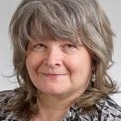 | Roberta Hoogervorst  Union Rep, UFCW832  Roberta Hoogervorst has been a Union Representative for over 12 years with UFCW Local 832. Previously, Roberta was actively involved with the union, serving as a shop steward, health and safety committee member and bargaining committee member at her workplace. Roberta is also very involved with Special Olympics Manitoba as her son Brett is an athlete with Special Olympics and participates in basketball, floor ball, swimming, golf, curling, and bowling.  During the 2018 Loblaw negotiations our bargaining committee at UFCW Local 832 was successful in adding ground breaking language to the contract where the Employer agreed to establish a joint employment project with the Union to hire and support persons with disabilities in the workplace. This was the first language of this kind to be bargained into a contract. We are excited to share this information to support others who are interested in starting these work integration partnerships and bring a focus to disability inclusion at work and strengthen this work nationally.
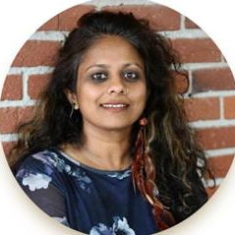 | Sahana Parameswara  Executive Director, Gateway Association  Sahana Parameswara is an uninvited guest in Amiskwacîwâskahikan and racialized ally to equity seeking groups including the pan-disability community. After a decade of immersing herself in trauma informed practices, cross-cultural therapeutic community modalities and working with systems that impact children and youth, she arrived at Gateway Association and has been the Executive Director for about 6 years. Her role is to hold space for the pan-disability community and their support network to build safe and inclusive spaces with equitable access that recognizes diversity. Her guiding values within this work are patience, love, courage, curiosity, creativity, and relationality. Sahana has a passion for creating a mindful work culture, equitable universal design principles, and deconstructing systems thinking. Spending time by the ocean is a privilege she enjoys periodically.
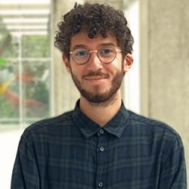 | Sami Fettah  phD, psychologue du travail, chercheur postdoctoral, Université de Montréal  Après avoir réalisé une double maitrise en psychologie du travail et ergonomie à l’Université de Picardie Jules Verne d’Amiens (France), Sami Fettah a réalisé sa thèse dans le cadre d’une Convention Industrielle de Formation par la Recherche (CIFRE). Cette opportunité lui a permis de réaliser son travail de recherche tout en occupant les missions d’un psychologue du travail et ergonome au sein d’un service de prévention et de santé au travail interentreprises. Il est actuellement postdoctorant au sein de la chaire ADO-PrevIT.
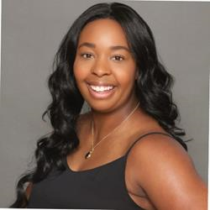 | Sarah Darrell  Inclusive Workforce Specialist, Sinneave Family Foundation  Sarah Darrell (she/her) is an Inclusive Workforce Specialist at the Sinneave Family Foundation. She focuses on creating ways to share knowledge with businesses about the need for and value of Neuroinclusion in the workplace. Through her Bachelors of Arts in Sociology and minor in Business, Sarah has strong foundational knowledge of diversity, equity and inclusion and its role in business. Her desire to open opportunities to diverse groups is matched with her knowledge of solutions for doing so, enabling her to share information to groups interested in being apart of inclusion not just in the workplace, but broader society.
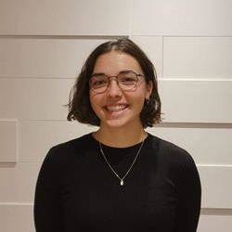 | Savanah Laurence  Student, University Laval - Étudiante en ergonomie et auxiliaire de recherche  Titulaire d’un baccalauréat en psychologie (2020) et d’une maitrise en ergonomie (2022), elle poursuit actuellement ses études au doctorat en sciences du travail et de l’emploi à l’Université Laval. Dirigée par les professeures et ergonomes Isabelle Feillou (Université Laval) et Marie Laberge (UdeM), elle s’intéresse au rôle des agents d’intégration dans l’accueil, l’insertion et le maintien en emploi des personnes en situation de handicap au travail.
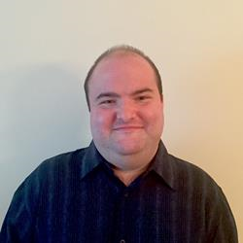 | Scott MacLellan  Administration, Northern Canadian Economic Development Agency - Deputy Minister’s Office and Communications Team  Scott is 39 years old with Joubert syndrome, a rare genetic disorder similar to cerebral palsy. I have a background in writing, with certificates in Media and Communications and Scriptwriting from Algonquin College. I’ve been an advocate for people with disabilities since my teens, speaking on behalf of Easter Seals, the Joubert Syndrome Foundation, where I also served as a member of their Board of Directors, and myself to families, students, Parliamentarians, and disabled youth, as well as writing articles for a couple disability websites and maintaining my own blog. I joined LiveWorkPlay in 2017 to look for work, and quickly got a job as an administrative assistant with Public Service and Procurement Canada in their Occupational Health and Safety division. Since 2022, I’ve been working with the Northern Canadian Economic Development Agency in an administrative role with their Deputy Minister’s office and Communications team.
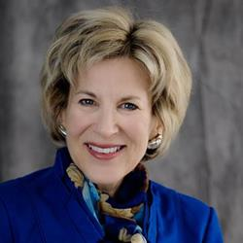 | Sherri Torjman  Social Policy Consultant, Sherri Torjman Associates  Currently a social policy consultant, from 1992 to 2017 Sherri Torjman was Vice President of the Caledon Institute of Social Policy, one of Canada’s leading social policy think tanks. In this role, she helped to propose and design the Canada Child Benefit and other income security and tax measures. From 2018 to 2022, Sherri served as Vice-Chair of the Disability Advisory Committee reporting to the Minister of National Revenue. She Co-Chaired the Technical Advisory Committee on Tax Measures for Persons with Disabilities in 2004 to 2005, reporting to the Minister of Finance and Minister of National Revenue. In 1987, Sherri wrote Welfare in Canada, developing the methodology still used today by Maytree for calculating social assistance incomes across Canada. Sherri worked for the House of Commons Committee on the Disabled in 1981 and wrote four books on disability policy for the Roeher Institute. She was a founding partner of the Vibrant Communities initiative focused on local solutions to reducing poverty. She is a Board member of Prosper Canada, an organization that works to expand economic opportunity for people living in poverty. In recognition of her policy work, Sherri was awarded the 2017 Senate 150 Anniversary Medal, 2012 Queen Elizabeth II Diamond Jubilee Medal, 2011 Champion of Human Services Award from the Ontario Municipal Social Services Association and 2010 Top 25 Canadians Award from the Canadian Association of Retired Persons.
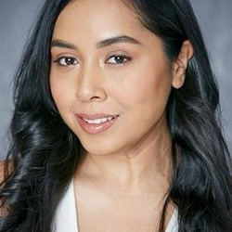 | Sinthea Chowdhury  National Project Coordinator, Ready, Willing & Able  Sinthea Chowdhury is a national project coordinator at Ready, Willing, able. Sinthea has spent the last 10+ years workings with BIPOC autism communities in Ontario, supporting them in building community capacity and in developing culturally relevant autism resources. Sinthea hopes to continue working with the many diverse disability communities throughout Canada and to further develop her intersectional lens.
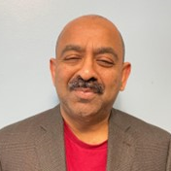 | Sricamalan Pathmanathan  HR & EE Coordinator, Toronto Metropolitan University  Sri is a person with dual sensory disabilities who immigrated to Canada from Sri Lanka in the early 90s. He is the cofounder of the Organization of Canadian Tamils with Disabilities and the Ethno-Racial People with Disabilities Coalition of Ontario, and serves as a board member with Race and Disability Canada and the Canadian National Society of the Deaf-Blind. Sri joined Toronto Metropolitan University in 1997 and is currently TMU’s Human Resources & Employment Equity Coordinator. He is a founding member and a current co-chair of TMU’s Employees with Disabilities Community Network and the Immigrant Employees Community Network.
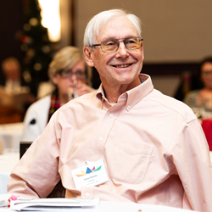 | Steve Mantis  Chair - Research Action Committee, Ontario Network of Injured Workers Groups  Steve was injured in an industrial accident in 1978 losing his left arm. He went through the Workers Compensation system and saw first-hand how it failed for many injured workers. It became apparent that many workers with a permanent disability became chronically unemployed and lived a life in poverty and depression. He has been active ever since working to improve the lives of injured and disabled workers across Canada.  Steve is the Founding member of the Thunder Bay & District Injured Workers Support Group, the Ontario Network of Injured Workers Groups and the Canadian Injured Workers Alliance. He is presently serving as Chair of the Research Action Committee of the Ontario Network of Injured Workers Groups (ONIWG) and sits on the Steering Committee of Disability & Work Canada (DWC).
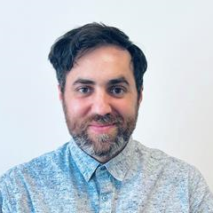 | Steven Lappano  Career Educator, Accessibility, University of Toronto  Steven Lappano (he/him) - Steven Lappano is a Career Educator, specializing in Accessibility at the University of Toronto. With over 15 years of experience in both non-profit and educational sectors, Steven focuses on working with learners with disabilities to expand their networks, achieve their career goals, and explore new opportunities, while developing self-advocacy skills in workplace and academic settings. Steven is passionate about working with employers and job seekers to create more equitable, inclusive workplaces.
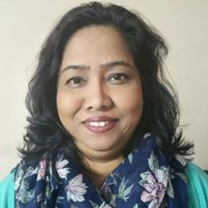 | Sultana Jahangir  Executive Director, South Asian Women's Rights Organization  Sultana Jahangir is a dedicated social service worker and advocate for social justice with 25 years of experience in Bangladesh, the United States, and Canada. After immigrating to Canada, she settled in Toronto’s East Danforth, home to many low-income Bangladeshi immigrant families. Here, she led immigrant women to establish the South Asian Women’s Rights Organization (SAWRO), where she has served as Executive Director since 2007. Under her guidance, SAWRO has launched impactful programs aimed at alleviating community poverty and empowering women and girls. Sultana holds a master’s degree in political and social science from Dhaka University and has pursued further education in North America.  Her commitment to women’s empowerment has been recognized nationally and internationally. She participated in the 2015-16 Canadian Women’s Foundation Leadership Institute and represented its alumni at the 2016 AWID Conference in Brazil, focusing on best practices in advocating for women’s leadership. Recently, Sultana was nominated for the “Enhanced Democratic Participation of Immigrant Women” project, which aims to improve employment access for immigrant women, funded by Status of Women Canada. As a leader in the Gender Equality Network Canada, Sultana draws on extensive experience to promote women’s rights and equality within her community.
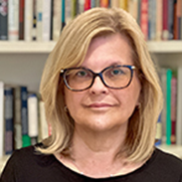 | Susan Silver  Associate Professor, Toronto Metropolitan University  Susan Silver is an Associate Professor in the School of Social Work at Toronto Metropolitan University. She has an MSW from the University of Toronto and PhD from Bryn Mawr College in Philadelphia. Susan is the former Director of the School of Social Work and the former Program Director for the MSW program. Her areas of interest include critical approaches to quantitative and qualitative research, community-based program evaluation, precarious work, and social welfare policy. Currently, Susan is exploring chronic illness and women’s health, as well as critical social work pedagogy. She is a Co-Chair of TMU”s Employees with Disabilities Community Network.
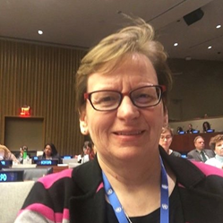 | Susan Hardie  Executive Director, Eviance  Dr. Susan Hardie (PhD, MSW, B.Ed., H.BSc.) is the Executive Director of Eviance, a community-based knowledge hub on cross-disability issues inclusive but not limited to mental health, and Adjunct Professor School of Health Policy & Management, Faculty of Health at York University.  She served as a Senior Policy and Research Officer and as a team member of the Mental Health Strategy Team, Mental Health Commission of Canada, that developed the first mental health strategy in Canada (2012), an evidence-based document that was informed by intersectionality, and reflexivity.  Dr. Hardie has dedicated her life to realizing transformative structural and system change in mental health and social justice as a policy analyst, researcher, educator, clinician, service provider, advocate, and grassroots community organizer in her community, provincial/territorially, nationally and internationally.  Throughout her career she has had a “foot in two worlds”, continuously working to bridge the ongoing gap between the collective, diverse lived experiences of persons with mental health issues, and the broader mental health and civil society stakeholders.
Susan Wallace

Section chief, Disability and Accessibility Statistics, Statistics Canada

Susan (she/her) is the manager responsible for the Canadian Survey on Disability, as well as other projects related to disability and accessibility statistics. Susan has been with the Disability and Accessibility Statistics section since 2020, and at Statistics Canada since 2006.
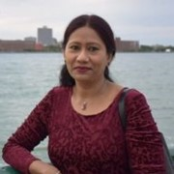 | Syeda Yesmin  Co-founder, South Asian Women’s Rights Organization (SAWRO)  Syeda Yesmin immigrated to Canada from Bangladesh in 2006 and has since been a resident of Toronto’s East Danforth area. Before her move, she worked as an elementary school teacher and was actively involved in student movements opposing military rule and advocating for workers' rights. Upon arriving in Canada, Syeda worked at McDonald's for a decade, often juggling multiple part-time jobs to support her family of four while managing a demanding schedule of up to 60 hours a week.  Despite her challenges, Syeda has been a proactive community organizer since 2007, co-founding the South Asian Women’s Rights Organization (SAWRO). Her experiences have fueled her commitment to advocate for the rights and welfare of immigrant women, aiming to create a supportive environment for those facing economic and social hardships. Syeda’s journey reflects resilience and dedication to community service, underscoring her belief in the power of collective action to bring about change.
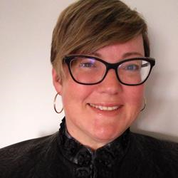 | Tara Beaton  Facilitator, Work Wellness Institute  Tara Beaton started her career in education before transitioning into disability management and vocational rehabilitation. With over 20 years of professional experience as a consultant, coach, leader and trainer, Tara has developed and delivered courses for York University, 3 Ontario community colleges, Pacific Coast University for Workplace Health Sciences, and VRA Canada. She maintains the RRP, RVP, CVRP, RTWDM, and CDMP designations, and she co-developed Canada’s certification examination for certified vocational rehabilitation professionals. In addition to her 2 undergraduate degrees, Tara holds a university diploma in Disability Management, and a master’s degree in Adult Education.
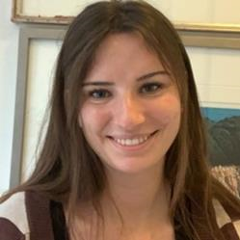 | Tess Kern  National Youth Episodic Disabilities Initiatives Coordinator, Realize  Tess Kern, MSW, RSW is a licensed social worker with a strong commitment to fostering empathy and compassion in her practice. After earning her Master of Social Work from the University of Toronto in June 2024, she began her role as the National Youth Episodic Disabilities Initiatives Coordinator at Realize. Tess brings a range of experience from her work in mental health support, research, and project coordination at institutions such as the University of Regina, Baycrest Health Sciences, and The Hospital for Sick Children. Her professional ethos centers on the belief that empathetic and collaborative care is essential to effective social services work.
 | Theresa Somerton  Self Advocate, Lifetime Abilities  Hello, my name is Theresa Somerton, and I live in Belleville, Ontario. I am a strong person who is passionate about dedicating my life’s journey to improving the lives of people with disabilities. I encourage people to champion their successes by speaking up for themselves. My passion is to promote inclusion and acceptance of all people. I inspire people to become more involved in their community, reach for their goals and dreams, share their talents with those around them to make a positive change in their community.  Theresa has taught at conferences and various organizations on advocacy educating community leaders and professionals about the need to be seen, not as a disability, but as a person who has, and will continue to bloom.
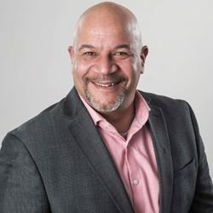 | Tim Holmes  Owner and Operations Manager, Faith's Furever Pet Needs & Resort  Tim co-owns with his spouse, Julie, 4 businesses (Unity T-A-C-K group, Faiths Furever Pet needs, Faiths Furever Dog Resort, Business/IT Consulting, Sting Chet-toos Tattoo Studio). Tim enjoys spending time with his family, enjoying nature, sports, gym enthusiast and enjoying time with the fureverbabies (families and clients alike). Tim enjoys giving back to his community through Connexion Works, Sain John Newcomers Center and Black Business Initiative where he serves as a mentor and often does inspiring and/or business speaking engagements. Through the family’s memorial fund in memory of their 2 children (Kiesha- May 2021 and TJ – Aug 2021) they raise money and donate to different organizations (Such as – The Royal Canadian Legen Veteran Affairs, Entrepreneurs who care, Compassionate Care Center,Hestia House, dog and cat rescues). Tim also serves as a senior strategic advisor through his company, Unity T-A-C-K Group, bringing over 28 years of IT experience in areas such as Infrastructure, Systems, DevOps, Cloud, Data Center, IT Security coupled with over 20 years of IT Executive leadership. Tim has lead teams with up to 60 direct reports through Private, Public, Government (union and non-union) sectors Internationally from start-up through to enterprise environments. He brings a customer centric, collaborative approach to making a positive valued impact to each business and personal relationship.
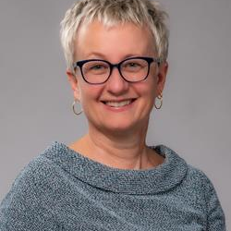 | Tina Namiesniowski  Senior Associate Deputy Minister of Employment and Social Development Canada and Deputy Minister Champion for Federal Employees with Disabilities, Government of Canada  On March 3, 2021, Tina Namiesniowski assumed the role of Senior Associate Deputy Minister at Employment and Social Development Canada. In addition, the Clerk appointed her Deputy Minister Champion for Employees with Disabilities in the Federal Public Service effective November 29, 2022. Ms. Namiesniowski has spent more than 30 years in the federal government. Throughout her career, she has accumulated a wide range of experience in policy, programs and operations and has a passion for public service.  Prior to arriving at ESDC, Tina worked in 8 different federal organizations, with the last 20 years at the executive level. She spent time in central agencies, including Privy Council Office as Assistant Secretary, Operations Secretariat, and line departments. Her program experience stems from her work as Director General, Multiculturalism and Human Rights at Canadian Heritage and as Assistant Deputy Minister with Programs Branch at Agriculture and Agri-Food Canada. She also served as Strategic Policy Assistant Deputy Minister, Public Safety Canada and Assistant Deputy Minister, Markets and Industry Services Branch at Agriculture and Agri-Food Canada. At the deputy level, she was most recently Executive Vice-President at the Canada Border Services Agency, following which she was President of the Public Health Agency of Canada during the biggest public health crisis of the century.  Tina’s career has greatly deepened her understanding of Canada, the citizens we serve and our contribution globally. She knows first-hand the stresses that organizations face in times of peril, what it takes to rise to the challenge and the importance of innovation. She is committed to service, policy and program excellence as well as continuous improvement. She cares deeply about people, diversity, inclusion, mental health and well-being.  Tina holds a bachelor of arts in political science and history from Carleton University. She also holds a master of arts in political science, with a concentration in strategic studies and international relations from Dalhousie University. She is married and has 3 children.
 | Tracey Halkyard  Equity Executive Board Member for Disabilities, Opseu/Sefpo  My name is Tracey Ann Halkyard, British born and have lived in Canada for 25 years. I identify as a deaf woman I am the Equity Executive Board Member for Disabilities Opseu/Sefpo. I am the first person to have won with her employer to have my hearing dog be with myself in my workplace which is a hospital. The challenges of disabilities and navigating through the corridors of privilege,ableism is exhausting but it doesn't have to be that way. I am a passionate advocate for education, change and equality. The lens that I work from is 'equality in equity. My mission is to support and provide strategic direction on inclusion topics and activities. I am committed to support and co create a culture where equity and inclusion principles are integrated into all aspects of our workplace. I am not afraid to be the voice for the voiceless. I am unwavering in my passion for an inclusive environment armed with spit and grit. As we wade through the silos together we can make the change by being the change. It is a great honor to be an advocate for disabilities and to have the dream of Universal design become the absolute norm.
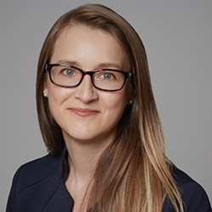 | Valerie Martin  Professor - Department of Organization and Human Resources, Université du Québec à Montréal (UQAM)  Valérie Martin is a professor in the Department of Organization and Human Resources at the Université du Québec à Montréal (UQAM). Martin is an IDEA Seed Grant recipient and co-chairs the UQAM’s “Working towards equity and inclusion for people with disabilities” committee. As an early career researcher, Professor Martin studies the organizational conditions that contribute to the inclusion of people with disabilities in the workplace. Her Ph.D. in psychoeducation was an evaluation of an employment support program for autistic individuals. Her research also highlighted the importance of supporting the relationship between a manager and their autistic employees as an essential component of inclusion.
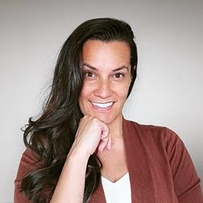 | Vanessa Wideski  Director of Community Impact & Sustainable Growth, Low Entropy  Vanessa Wideski is the Founder of Low Entropy, a nonprofit organization focused on empowerment and personal development. As the co-chair of TEFA (Tri-Cities Employment For All) and board chair for Community Action Initiative, she is dedicated to fostering inclusive work environments. Vanessa is experienced in developing best practices that ensure accessibility and respect for all employees. Her work focuses on removing barriers to employment for marginalized communities and creating workplaces where diversity is celebrated. Vanessa’s leadership emphasizes the importance of belonging, inclusion, and equity in professional spaces.
 | Vanessa Sinclair  Manager, Research & Evaluation, CCRW  Vanessa Sinclair, PhD is a social scientist and Manager of Research and Evaluation at the Canadian Council on Rehabilitation and Work (CCRW). Vanessa received her doctorate in social psychology at Western University, and has been leading and collaborating on accessibility and employment research at CCRW for the past 3 years.
 | Yvonne Spicer  Self Advocate, Lifetime Abilities  Yvonne has spoken loudly for the inclusion of all people, locally, and around the world, presenting at political events. Yvonne encourages people to rely on their strengths by championing their successes. She makes sure that rights for all people are acknowledged.  For many years, Yvonne has shared her passion for inclusiveness through presentations, keynote speeches, workshops, and collaborative projects. Some of the topics are: Individualized Planning, Advocacy, Autism, and with the New Vision Advocates, Spicer presents Power of Words and Labels. Yvonne has been recognized for her advocacy on social issues, especially on the topics of human and disability rights, combating poverty, as well as innovative housing, and employment opportunities.  In 2023, Yvonne released a book for purchase by the public, titled My Life, My Choice, My Future. In her book, Yvonne focuses on the obstacles and successes that a person may experience in life.  Yvonne is a tireless advocate, who is not afraid to speak up, and is confident that all people who have an intellectual disability can achieve a life of their dreams when they are in charge.

