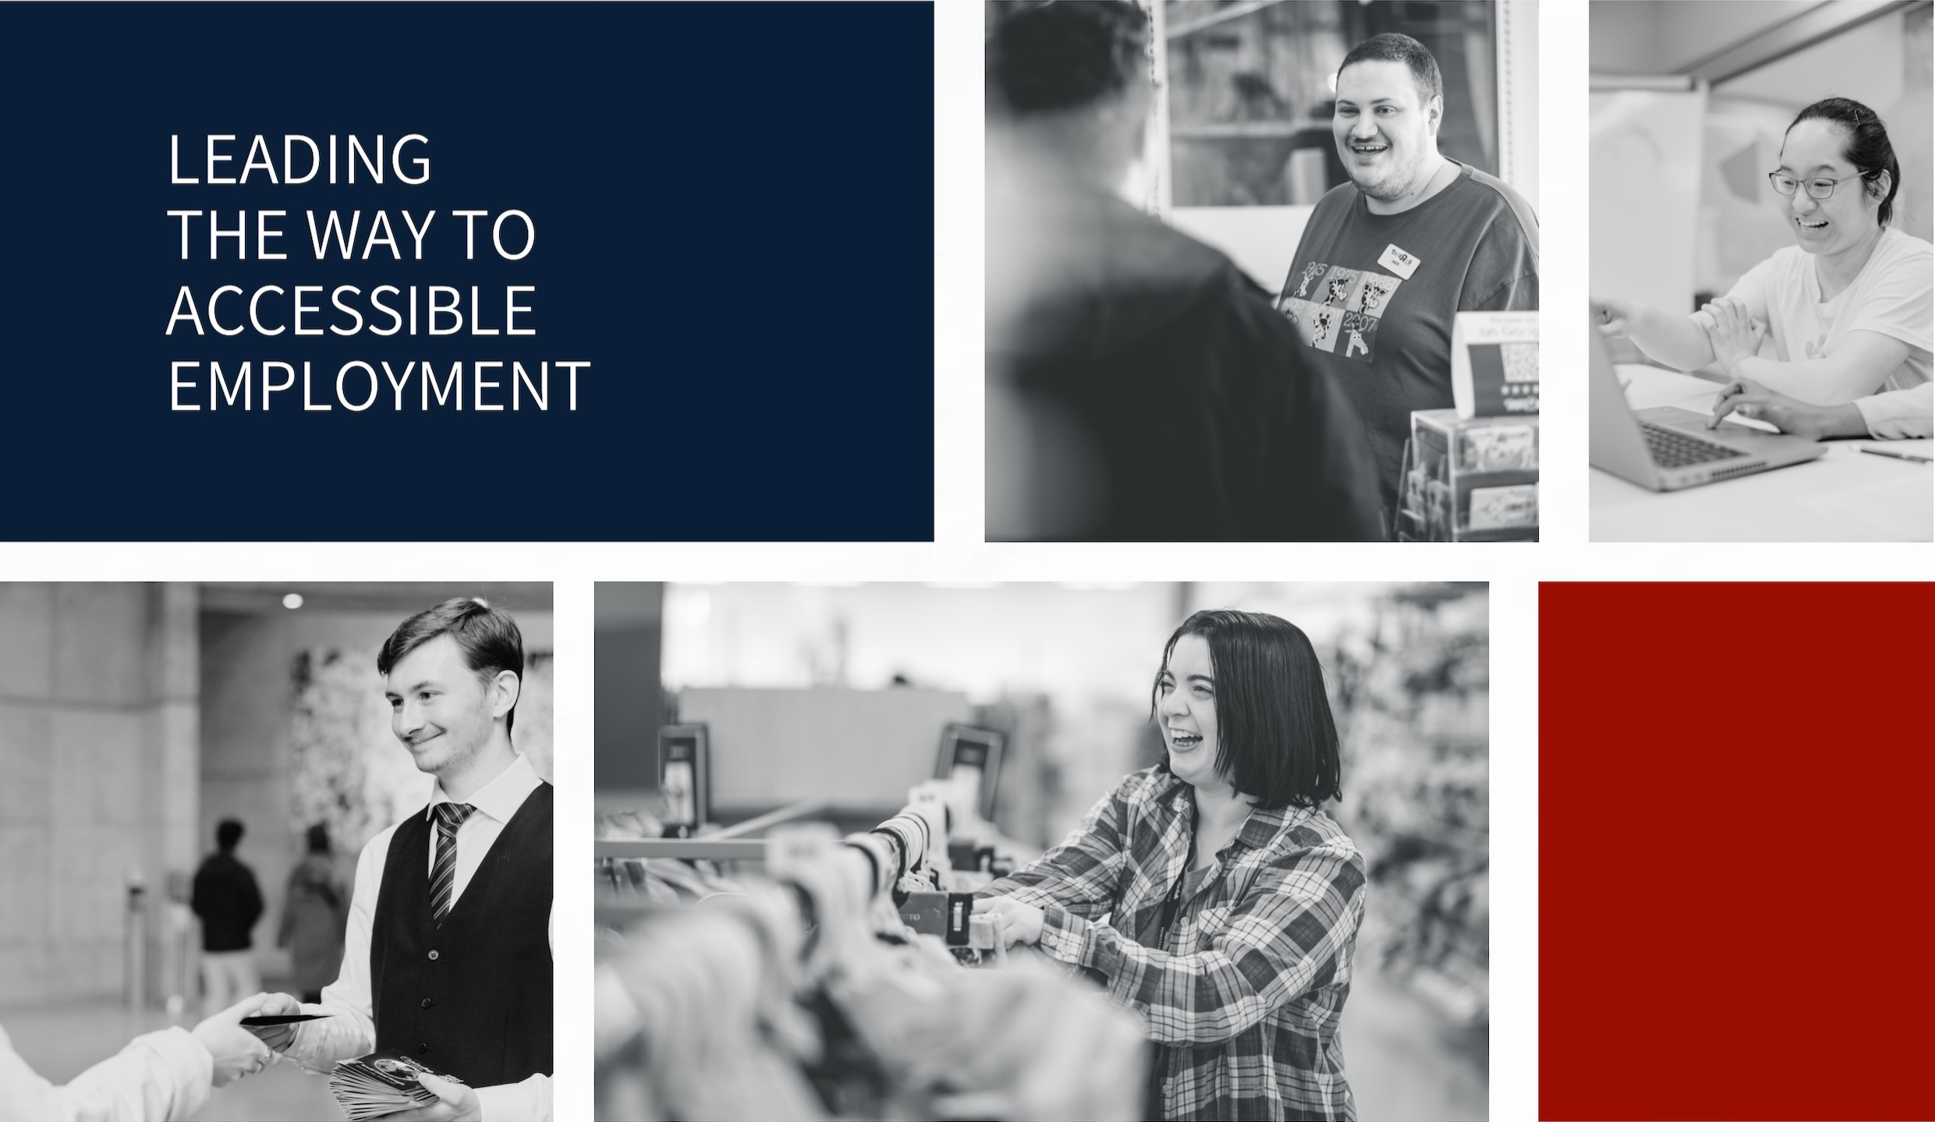
Sourcing Understanding Through Research for Future Talent (SURF)
Executive Summary
March 31, 2026
Authors:
Vanessa Sinclair, PhD, Director of Research & Evaluation
Michelle Willson, MA, Evaluation Specialist
Canadian Council on Rehabilitation and Work

This project was made by possible by the financial support of Accessibility Standards Canada. The findings, conclusions, and recommendations presented are those of the authors and do not reflect the official views of Accessibility Standards Canada.



This document may be used and shared provided that Canadian Council on Rehabilitation and Work is credited as the source, the contents are not modified, and the use is non-commercial. For permission to modify the content and/or use it for commercial purposes, please contact the Canadian Council on Rehabilitation and Work.

Executive Summary
This report shares what we learned from Sourcing Understanding Through Research for Future Talent (SURF). SURF was a three-year study on how students with disabilities in Canada move from college or university into work. The study looked at the challenges new graduates face, what supports help, and what changes could make looking for work easier and fairer.

How the Study Was Done
SURF used surveys and focus groups to learn about students’ experiences. Students filled out the first survey when they were close to graduating. Some of them filled out a second survey about a year later. After checking the data, 288 students with disabilities were included in the first survey. Forty-two students completed both surveys. Most were university students. Many students had mental health disabilities, and many students had more than one disability. A smaller group of students also took part in focus groups to share more details about their experiences in school.

Key Findings
Moving from college or university into work was hard for many graduates. About 6 in 10 graduates had found jobs, but only about 1 in 3 of them had a permanent, full-time job.
Looking for work often took longer than graduates expected. Many thought they would find a job within a few months, but more than half said the search took longer than they had hoped. Graduates with multiple disabilities took longer to find work than graduates with one disability. Some graduates were still looking for work at the follow-up. They had been searching for about a year, on average.
Pay was often lower than expected. More than half of graduates with jobs said they earned less than they expected in their first job. Many had very low incomes.

Biggest Gaps (and What Could Help)
The biggest barrier in the follow-up survey was that many entry-level jobs asked for more experience than graduates had. Bias was also a problem. Almost 1 in 4 participants said they faced discrimination from employers. Participants also talked about other challenges, such as transportation, trouble getting health care supports during the transition, and money stress while looking for work. In focus groups, many said the move from school to work felt stressful and uncertain, especially when they were not sure what to do next or how to handle interviews and workplace expectations.
Some actions could help make the move from school to work easier:
- Early work experiences that include everyone. Co-ops, internships, work placements, and networking can help students get their first job. But these opportunities are not always easy to access for students with disabilities. Participants said students need more support to build connections, such as mentorship and networking. They also said employers need to be clearer about what accommodations they will offer.
- Career services that are easy to use, useful, and informed about disability. Participants did not always think school career services were helpful. Some did not know what help was available. Others said the support was too general or hard to access. Career services could do more to help if staff had better training about disability. They could also offer more practical support related to students’ fields of work.
- Better links between supports. Job search support is often spread across many places. It should be easier for graduates to find and move between school accessibility services, school career services, and community services. Schools and community organizations need to work together to make these pathways clearer.
Next Steps
Because only a small number of people completed the follow-up survey, we could not be sure about some patterns, such as differences by gender or ethnicity. Future research should use larger national datasets, like the National Graduates Survey. More studies are also needed to test what actions will help graduates with disabilities the most, like how to make work-learn programs in schools more accessible, or create networking opportunities for students.

